 

User guide

Management of accredited classifiers

September 2024

# Introduction

This user guide is for these functions in the Classification Portal at [classificationportal.classification.gov.au](http://classificationportal.classification.gov.au):

* submitting an accreditation request to become an accredited classifier under section 22M of the *Classification (Publications, Films and Computer Games) Act 1995* (Classification Act)
* seeking approval for the ‘accredited classifier’ role in an organisation
* assigning the ‘AC manager’ role in an organisation.

Under section 22K of theClassification Act, an accredited classifier is a person approved by the Secretary of the department to classify films and/or computer games on behalf of organisation/client(s). The accredited classifier role is only available to those users who have been approved.

The organisation is the publisher or distributor of the film or computer game.

You can learn more about accredited classifiers at [classification.gov.au/for-industry/accredited-classifiers](http://www.classification.gov.au/for-industry/accredited-classifiers).

You can learn how to link organisations in the Portal FAQ user guide at [classification.gov.au/for-industry/frequently-asked-questions-and-guides](https://www.classification.gov.au/for-industry/frequently-asked-questions-and-guides).

# Before you start

Before you start, you must:

* have a Portal account
* know the organisation/client name in the Portal
* know the administrator of the organisation in the Portal.

If you do not know the administrator, please contact your organisation/client.

# Submitting an accreditation request

1. Log into the Portal and select **Profile Management**.

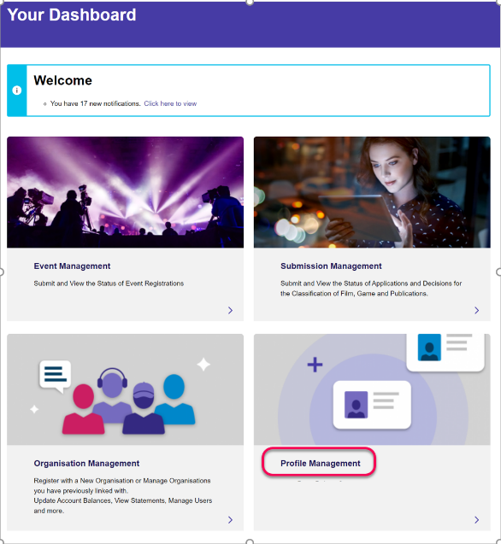

1. Select **Accreditation Requests** from the Profile Management menu.

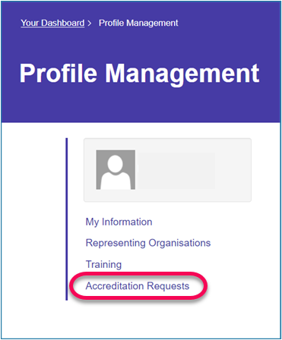

1. Select **Create New Request.** The Accreditation Requests page will display any existing accreditation details.

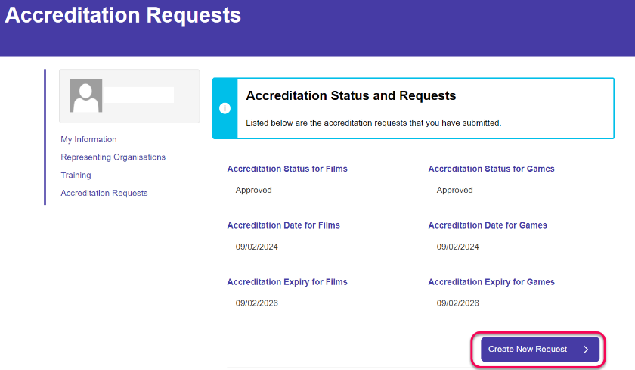

1. Read the information about AC Applications and select the relevant option for either **New Request** or **Renewal**, then **Save and Next.**
   1. Select **New request** if you are applying for accreditation for the first time.
   2. Select **Renewal** if you are accredited and your accreditation is about to, or has, expired.

You can submit the renewal:

* + 1. before your accreditation expiry date. If approved, you will be accredited for 2 years from the approval date.
    2. on or after your accreditation expiry date. However, you will lose access to the accredited classifier functions in the Portal when your accreditation expires, until you have been accredited again.

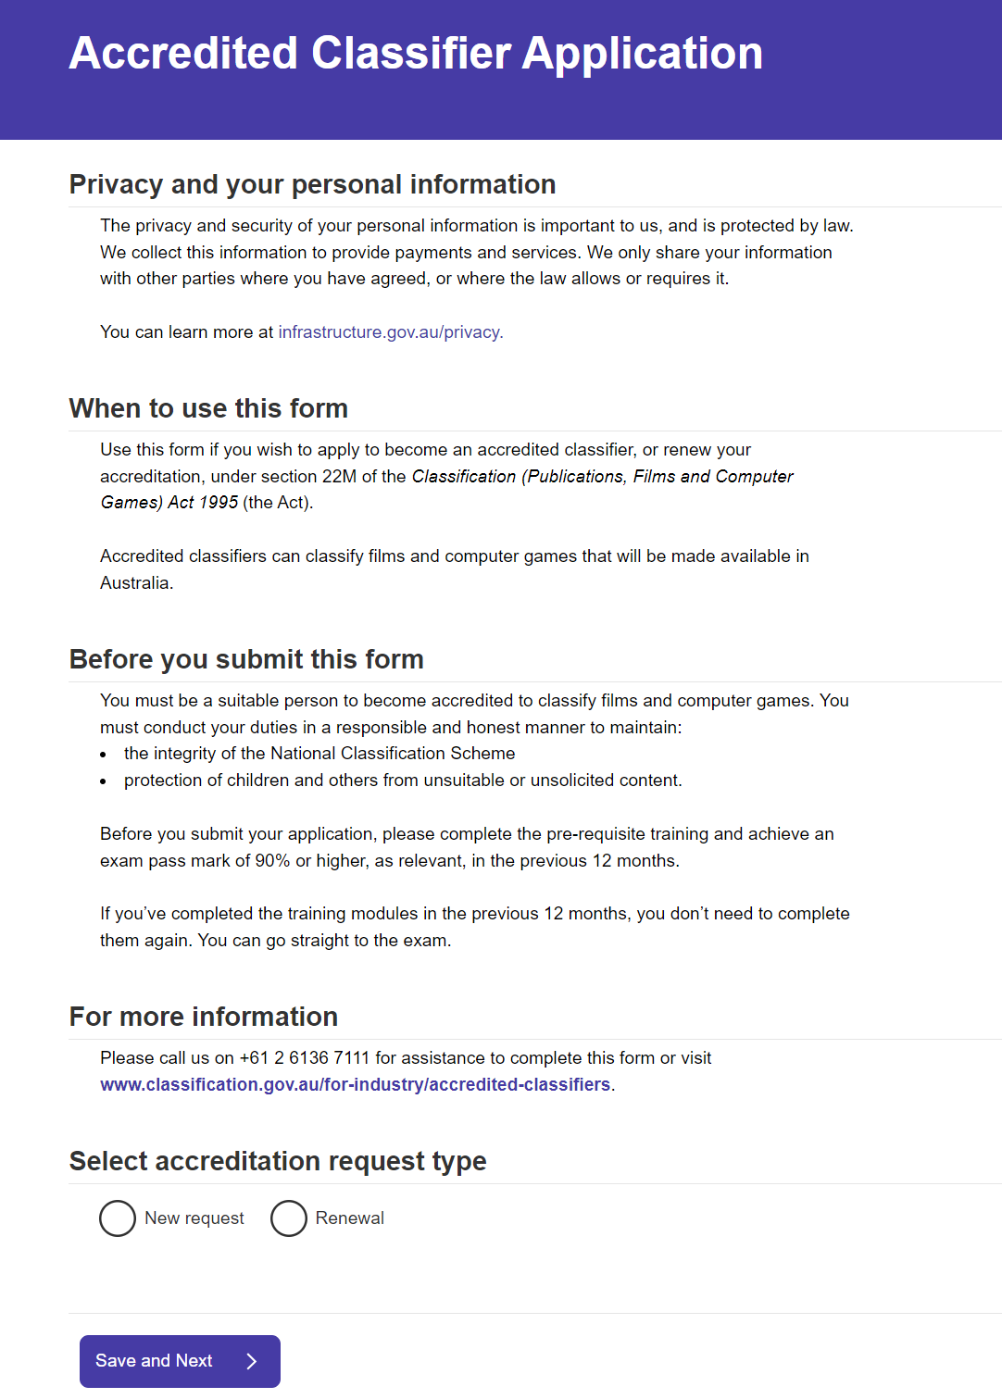

1. Check if your contact details are correct, then select **Save and Next.** If you need to update them, select **Profile Management** and update your details.

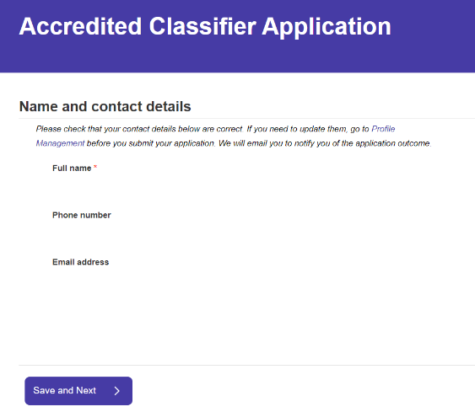

1. Select the relevant radio buttons for:
   1. the type of content you wish to classify
   2. if you have completed the relevant training in the past 12 months, and
   3. if you have completed the relevant exam and achieved a mark of 90% or higher in the past 12 months.

If you select no to the training and/or exam questions, a message will appear instructing you to do so before submitting your application.

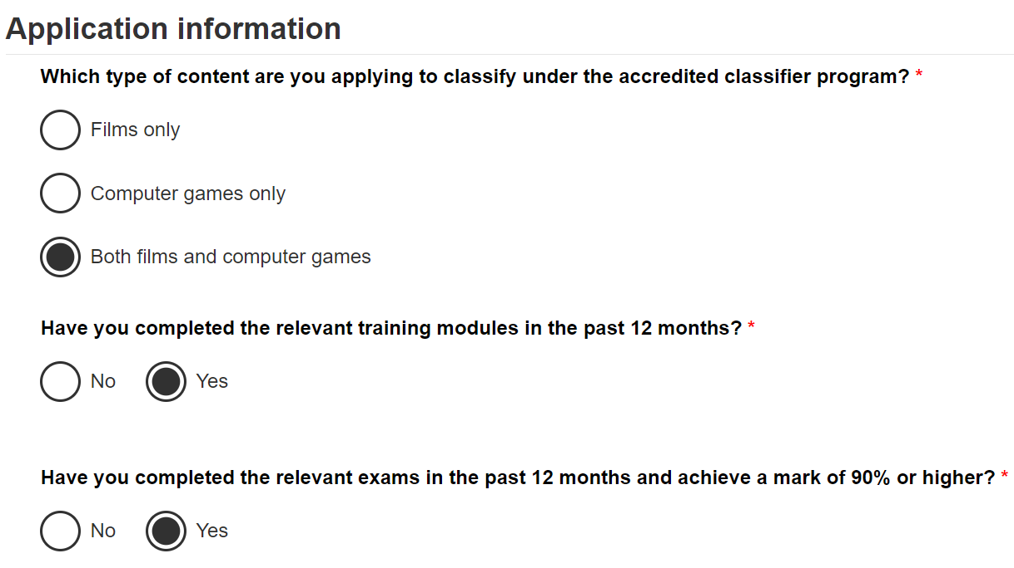

1. Select the radio buttons for the below questions, and then select **Save and Next**.
   1. Suitability to become an accredited classifier.

If you select yes to this question, a free text field will appear.

Please input text in this field to explain why you have selected Yes, including any offences you have been convicted of relating to fraud and dishonesty, or any involvement in an organisation which may be inconsistent with your suitability to classify films and computer games, or any other relevant matter. You can also include an explanation of how you believe that despite this, you have the ability to uphold the integrity of the National Classification Scheme and protect children from harmful content.

* 1. current or previous status as an authorised assessor.
  2. revocation of status as an authorised assessor.
  3. barring notices as an authorised assessor.

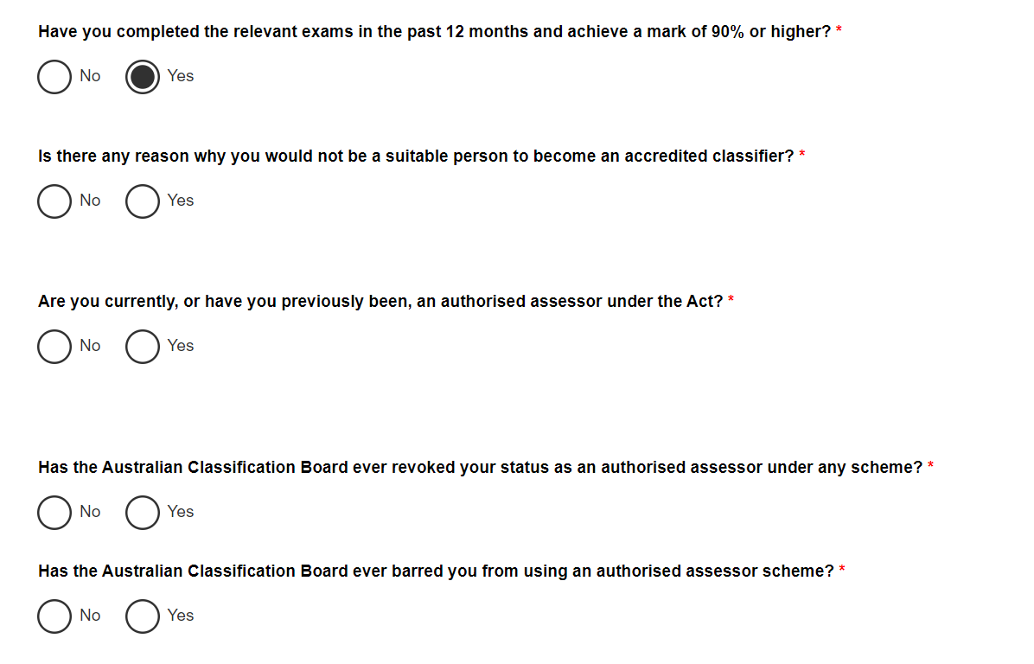

1. 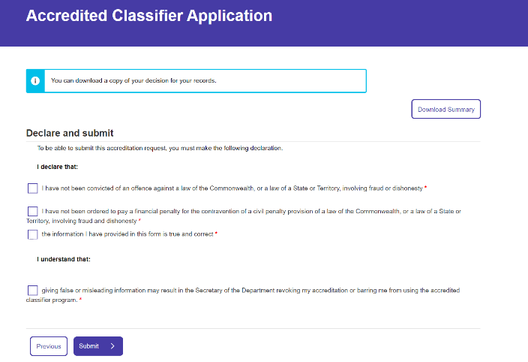You can download a summary of your Accredited Classifier application by selecting **Download summary.** Then, review the declaration and select the tick boxes to agree and select **Submit.**
2. A message will appear notifying you that your application has been submitted.

The department will process your application and notify you of the outcome via the email address provided on your application.

# Requesting the ‘accredited classifier’ role in an organisation

To submit a decision as an AC on behalf of your organisation/client, you must first be approved as an ‘accredited classifier’ for the organisation in the Portal.

1. Select **Profile Management** from Your Dashboard.

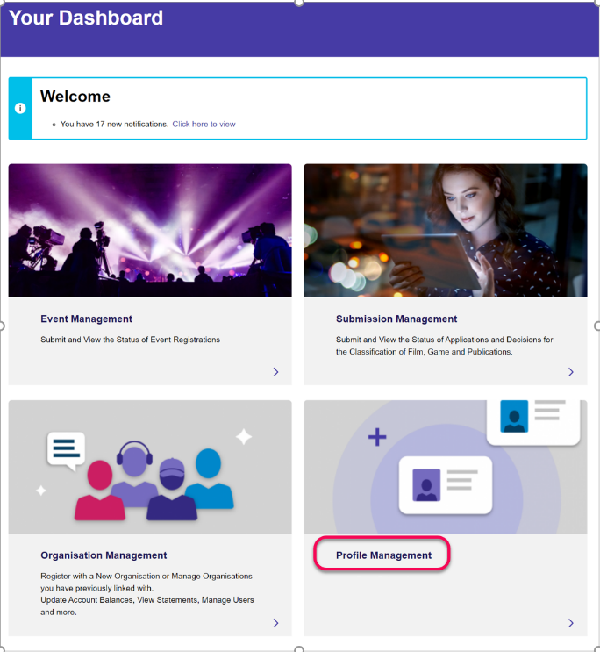

1. Click **Representing Organisations.**

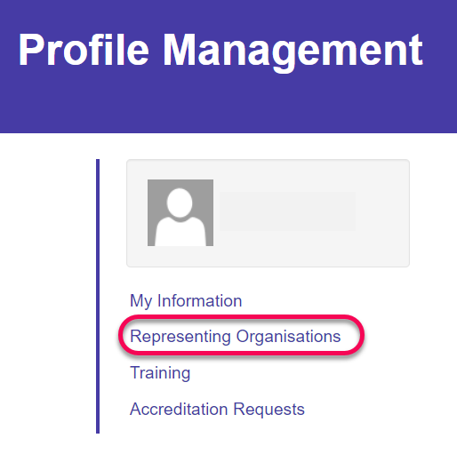

1. Select **Add Another Organisation** to add the organisation you will be submitting on behalf of.

If you are already part of the organisation, please contact the administrator of the organisation and ask them to approve you as an AC using the steps in Approve an AC to submit decisions on behalf of your organisation.

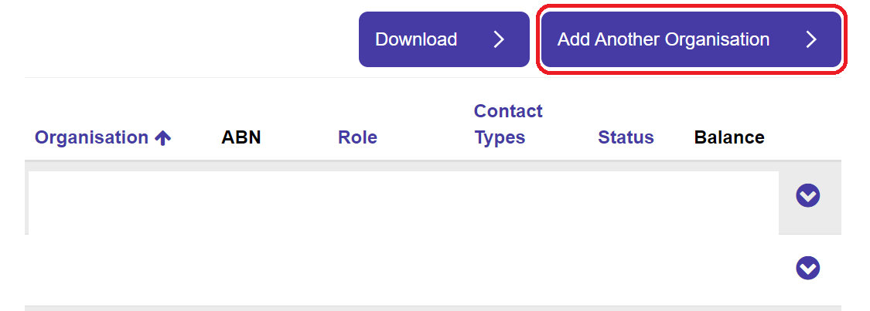

1. Enter the name of the organisation and select **Next**.

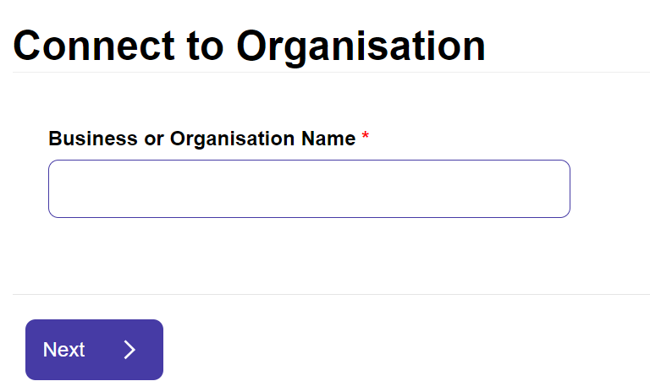

1. Select the organisation from the search results then select **Next**.

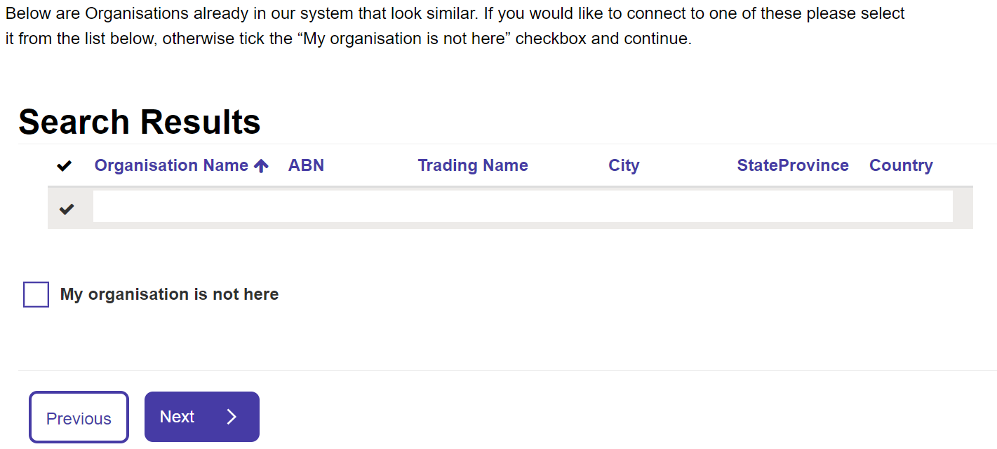

1. Review the information and select **Accept Confirmation**. Then select **Submit**.

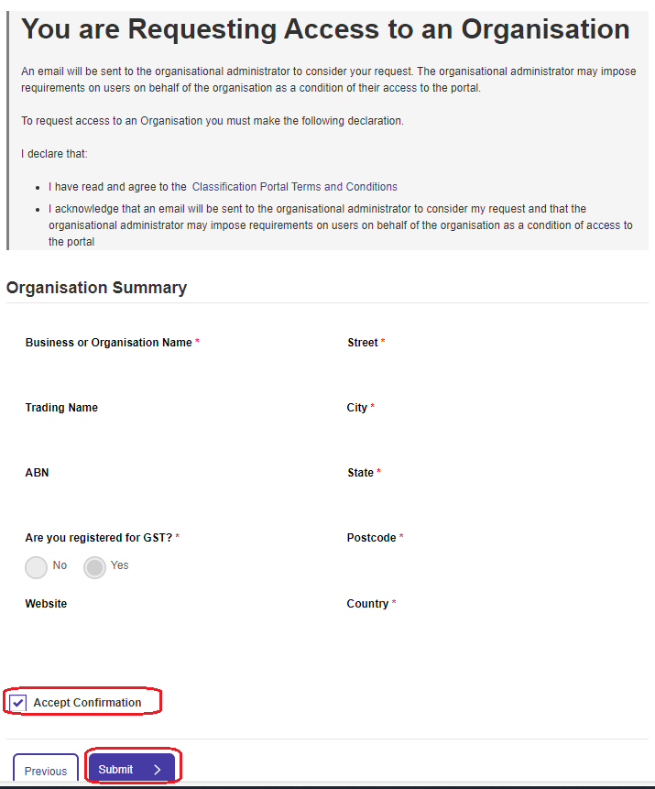

The administrator will be notified of your request. Once they approve your request, you will receive a notification in the Portal.

# Approve a user who has requested the ‘accredited classifier’ role in your organisation

The administrator of an organisation must approve a user as the ‘accredited classifier’ role before they can submit decisions on behalf of the organisation. The administrator will be notified when a user requests the role in the Portal.

Please note that users approved for the ‘accredited classifier’ role are able to view all submissions made for your organisation.

1. Select **Profile Management** from the main Portal Dashboard. 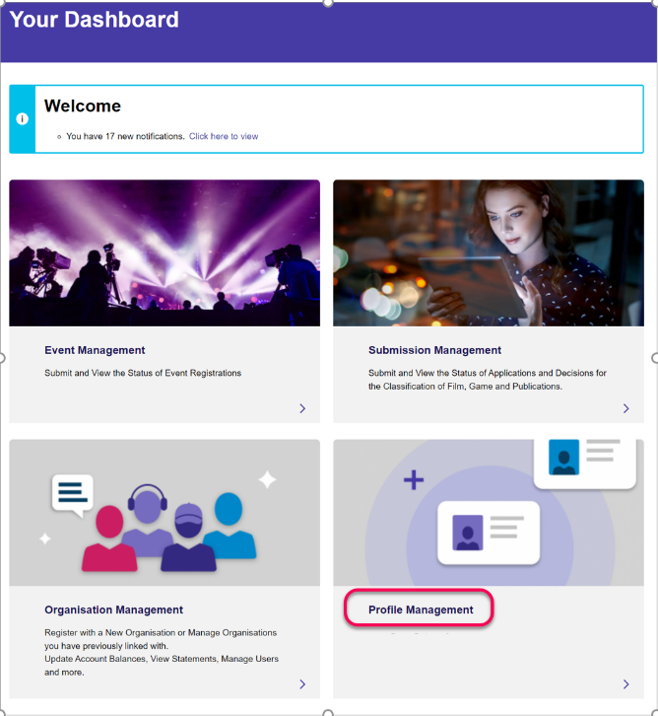
2. Select **Representing Organisations**.
3. 
4. Select the organisation you wish to approve an AC for by selecting the downward facing chevron, then **View Details.**

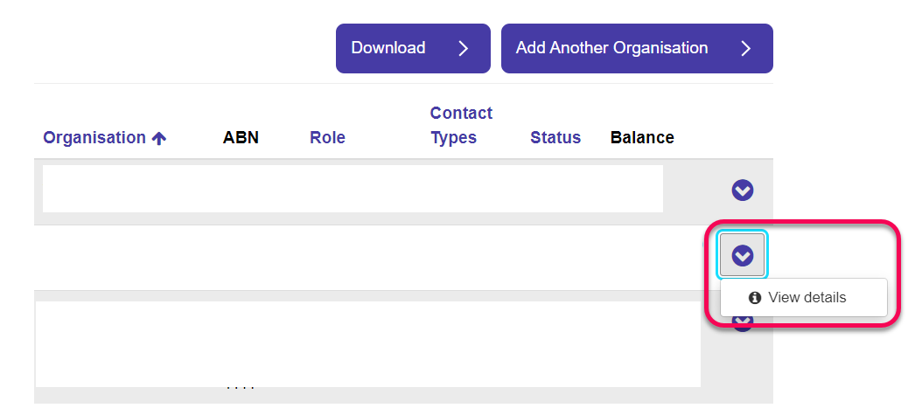

1. Select **Manage Users**.

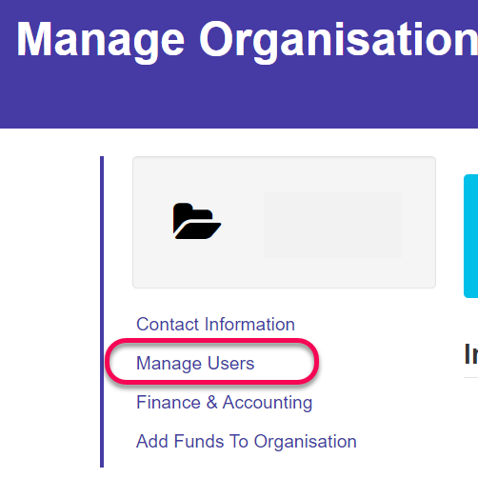

1. Select the user requesting to be an AC for your organisation.
2. Select the downward facing chevron to the right of their name and select **Update Access.** 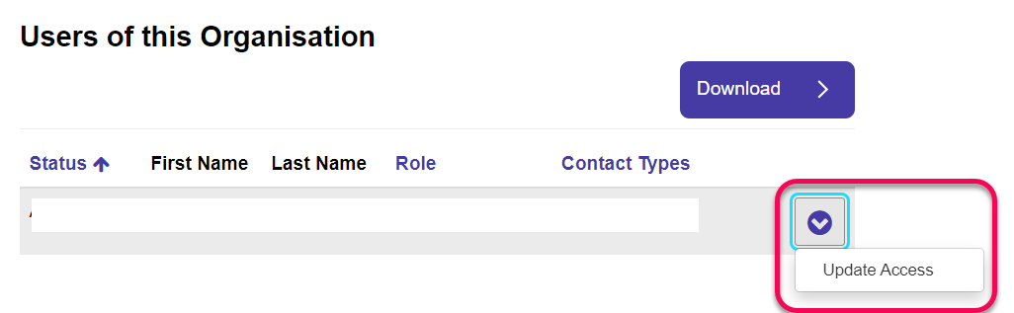
3. Select the User role ‘Accredited Classifier’ then select **Save Changes**. 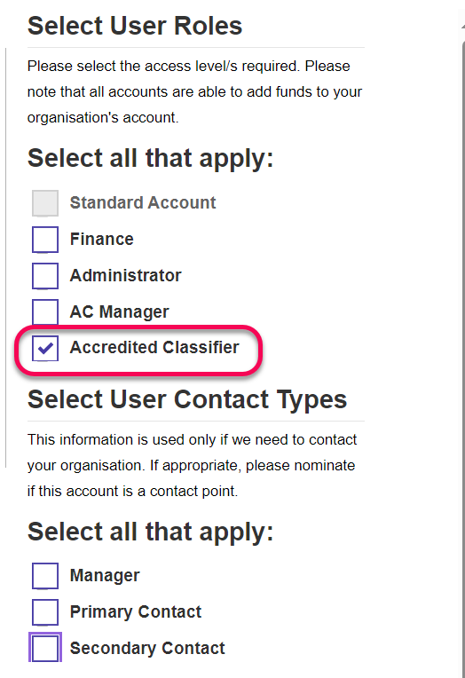

The AC will receive a notification that they are now able to submit classifications on behalf of your organisation.

# Assigning an ‘AC Manager’ for your organisation

The AC manager is the user in your organisation who you have nominated to receive any correspondence relating to decisions made by user(s) with the accredited classifier role.

1. Select **Profile Management** from the main Portal Dashboard. 
2. Select **Representing Organisations**.
3. Select the organisation you are assigning an AC Manager to by selecting the downward facing chevron, then **View Details.**



1. Select **Manage Users**.



1. Select the user who is the AC Manager for your organisation, then select the downward facing chevron to the right of their name and select **Update Access.**
2. Select the User role ‘AC Manager’ then select **Save Changes.**

