 

User guide

Submitting an accredited classifier decision for a computer game

November 2024

# Introduction

This user guide is for submitting a classification decision (decision) for the purposes of section 22K(2) of the *Classification (Publications, Films and Computer Games) Act 1995* (Classification Act) in the Classification Portal (Portal) at [classificationportal.classification.gov.au](https://classificationportal.classification.gov.au).

To learn more about accredited classifiers, go to [classification.gov.au/for-industry/accredited-classifiers](http://www.classification.gov.au/for-industry/accredited-classifiers).

# Before you start

Before you start, you must:

* have a Portal account.
* be accredited as an AC.
* have the ‘accredited classifier’ role assigned to you for the organisation for which you are submitting the decision on behalf of.
* have the following information for your AC decision:
  + the organisation that requested you classify this game
  + the title or file number of any previous decision for the computer game, if relevant
  + the title
  + any other titles (English and Foreign language)
  + development studio/developer
  + publisher
  + production year
  + embargo information
  + synopsis
  + release date of the game
  + date you were requested to make the classification
  + date the content was viewed
  + impact level of each classifiable element (themes, violence, language, nudity, drug use, sex)
  + consumer advice as per the list issued under section 12A of the Classification Act
  + a brief explanation why the classification (rating) and consumer advice were given to the game, focusing on the classifiable element(s) that are most impactful
  + anything else you wish to tell us about the content in the game, such as materials that may be contentious or sensitive. This might include simulated gambling, a link between incentives/rewards and nudity, drug use or sexual activity, sexual violence, family violence, self-harm, suicide or mental health themes.

You can learn how to link organisations in the **Portal FAQ** and how to request the ‘accredited classifier’ role in the **Management of accredited classifiers user guide** at [classification.gov.au/for-industry/frequently-asked-questions-and-guides](https://www.classification.gov.au/for-industry/frequently-asked-questions-and-guides).

## Submitting an AC decision for a computer game

### Initial Navigation

1. Log in to the Classification Portal, select **Submission Management**.



1. Select **Create New Submission**.

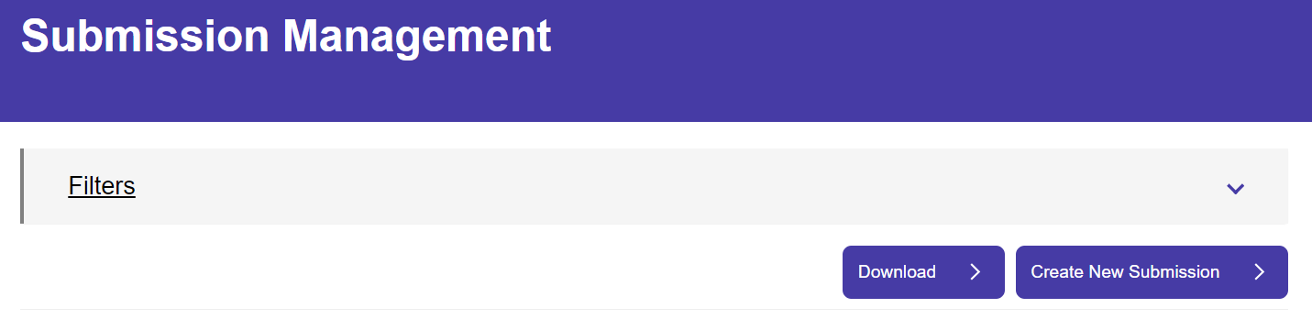

1. Select **Computer games**.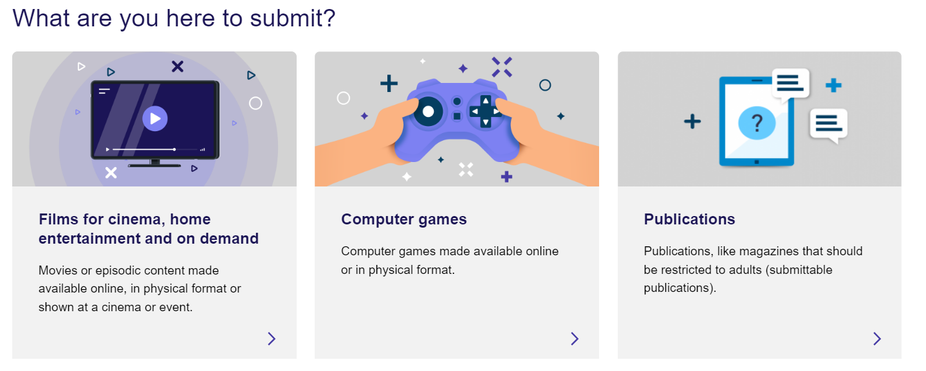
2. Select **Classification**.

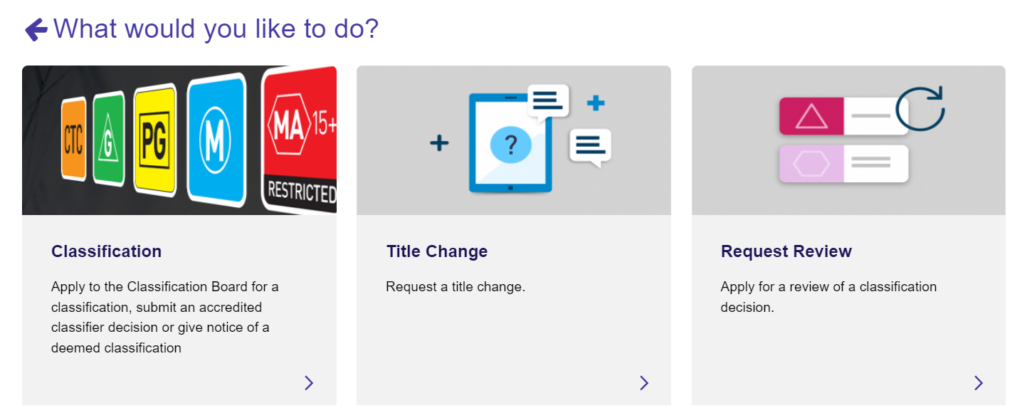

1. Select **Submit an** **Accredited Classifier decision**.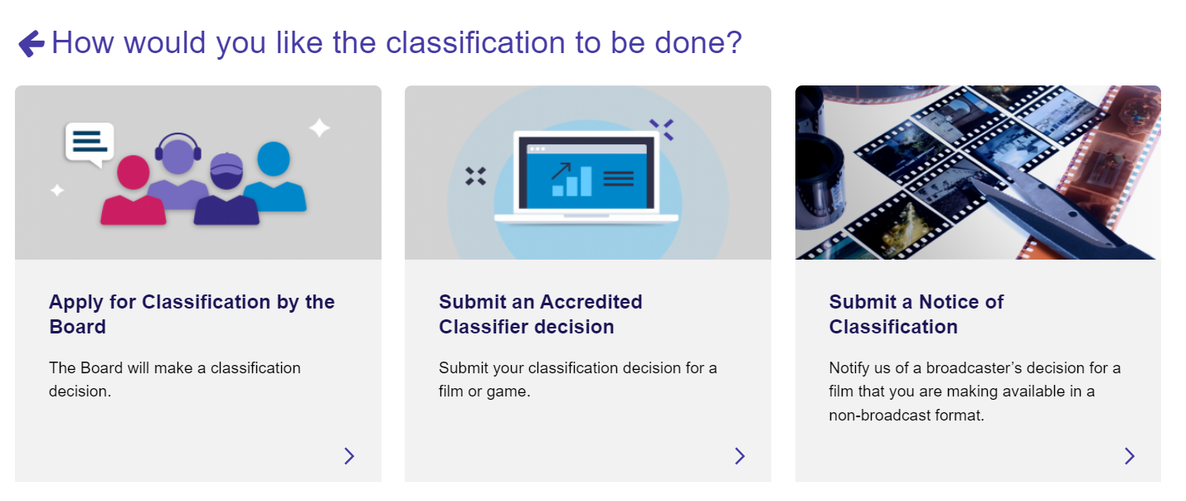
2. Select your organisation from the drop-down list then **Next**.

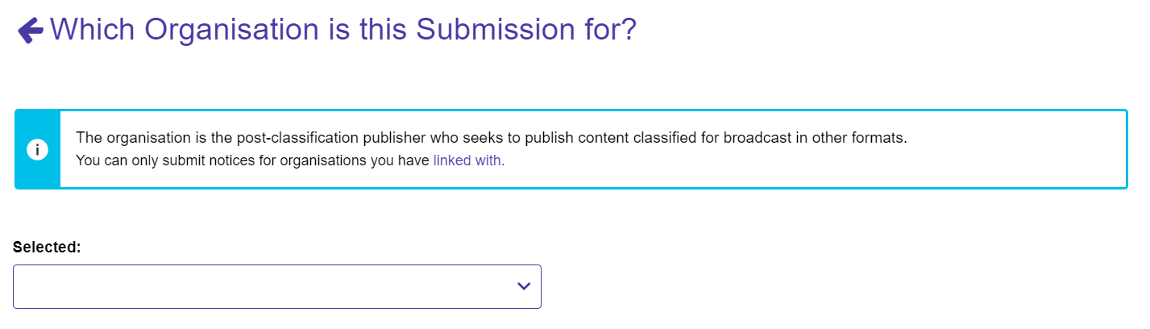

1. Select the relevant tile for ‘Is this submission related to a previous decision’:
   1. If you select **No**, go to step 9.
   2. If you select **Yes**, go to step 8.

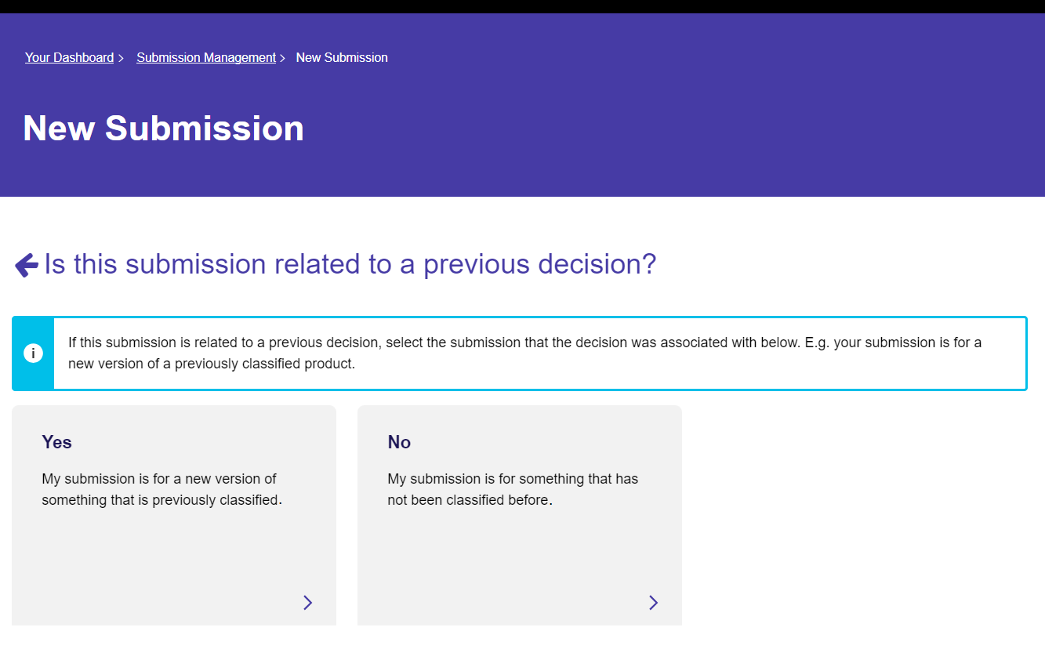

1. If the submission is for a computer game that has been classified previously:
   1. Select **Click to Search**, this opens up a search screen.

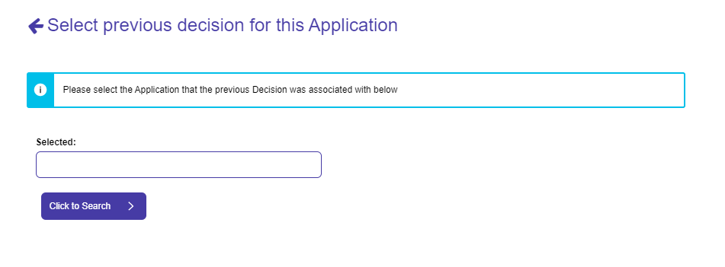

* 1. You can search by: File number, Title (exact title yes/no) or keywords, then select **Search.**

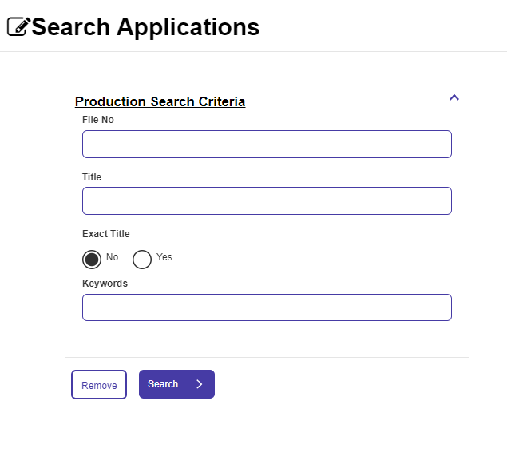

* 1. To get to the “Select” button in this case, you may need to use the scroll bar on the right-hand side and drag it down. Once it appears, choose **Select** then **Start Submission**.

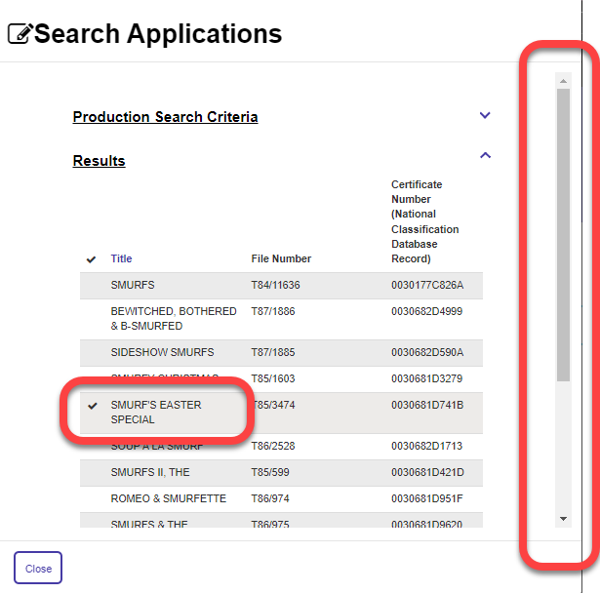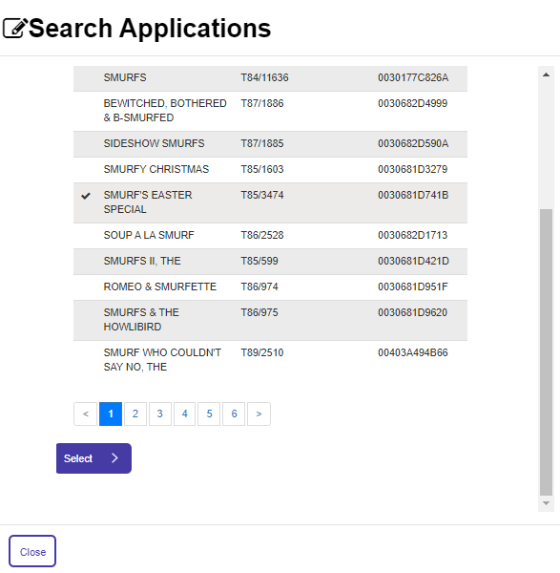

### Basic details

1. Use the toggles to expand the sections on this page. Mandatory fields are marked with *.
   1. If you completed step 8, the information from the original decision will appear.

Keep any information that still applies, and edit any that has changed for this version.

* 1. Input all the relevant fields and then select **Save and Next**.
     1. For **Dev Studio/Developers name(s) and Publisher name(s)**, select **Add** and then enter each name one at a time. If there are multiple names, you must repeat this step for each one.
     2. For **Production Year,** enter a four-digit number (e.g. 2022).
     3. For **Language,** use the look up function to search for a language. Select a language and/or subtitle language, then select **Add Language**. If there are multiple languages, you must repeat this step for each one.

Language is set to English by default, you may delete if required.

* + 1. For **Country of Origin,** use the look up function to search for a country. Select a country then select **Add Country**. If there are multiple countries, you must repeat this step for each one.

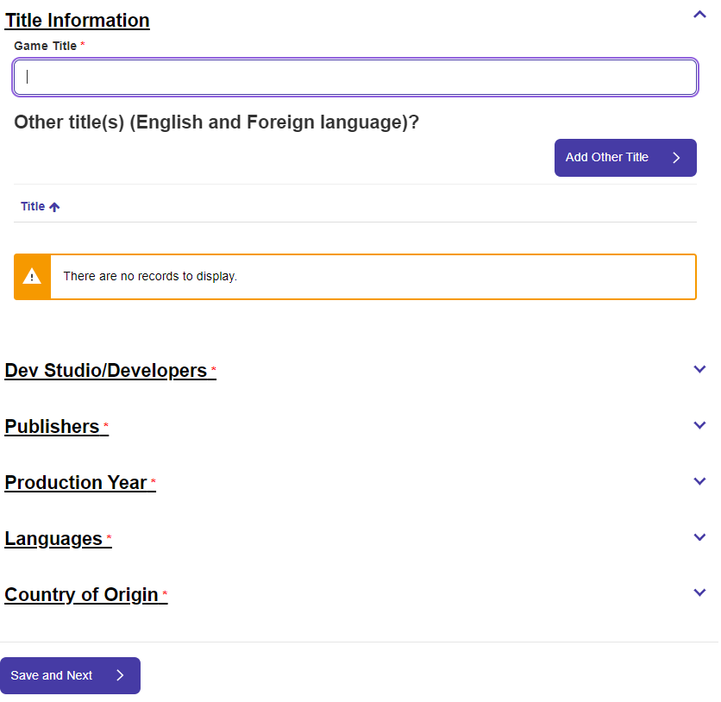

### Additional information

1. Use the toggles to expand the sections on this page. Input relevant fields and then select **Save and Next**. Mandatory fields are marked with *.
   1. For **Embargo information**, enter the information as relevant
   2. For **Synopsis, release date and Game DB URL:**
      1. add a synopsis, if relevant
      2. input a release date (DD/MM/YYYY)
      3. input the Games DB URL, if available.
   3. For **Classification requested by:**
      1. the company will auto-populate based on the organisation you selected at Step 6
      2. select the classification request date as per the date the organisation requested you to classify the game
      3. select the date you viewed the game. This date must be on or after the classification request date.

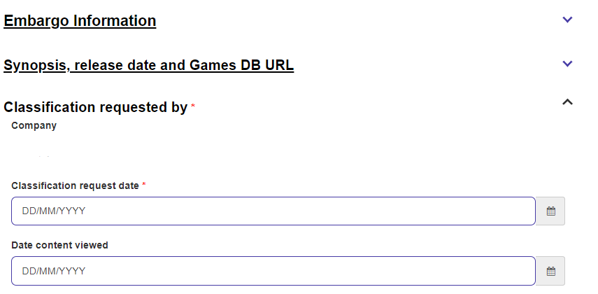

### Rating

1. Enter a value for each classifiable element (element). Select the chevron and select **Edit**, select the rating from the drop-down list, and select **Submit.** If the element is not present in the content, select ‘None’. Repeat for each element.

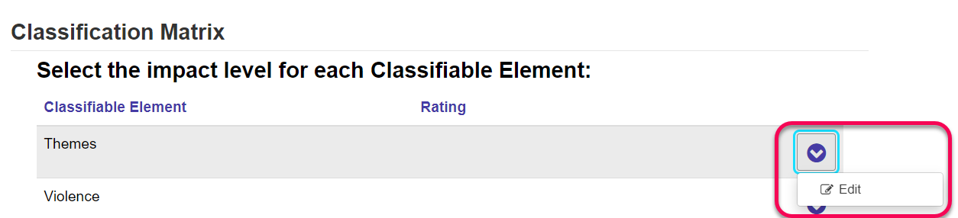

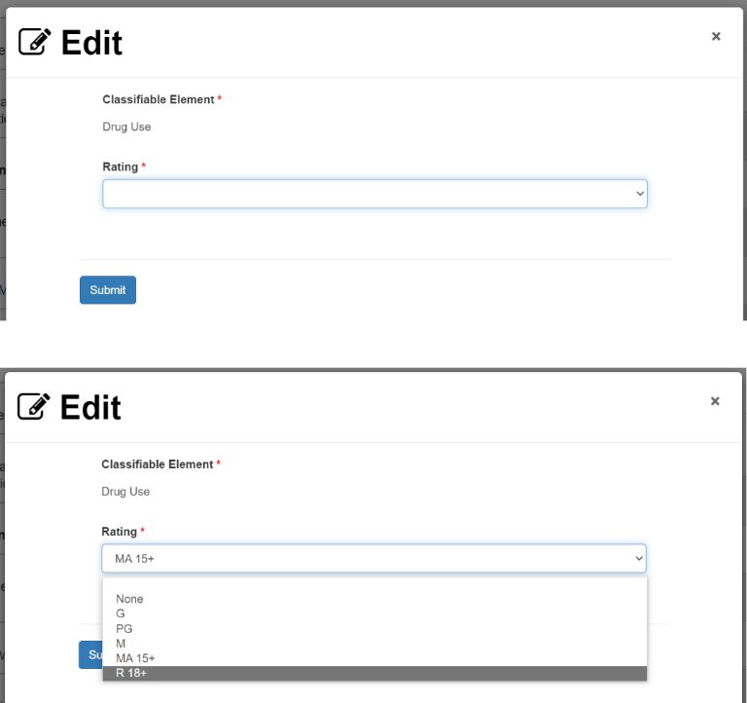

1. After you have selected a rating for each element, answer the question “Does the game contain chance-based in-game purchases?”

**You must select “Yes” if your game contains chance-based in-game purchases. Chance-based in-game purchases consumer advice terms are only available under ‘Themes’ on the next page if you select “Yes” to this question.**

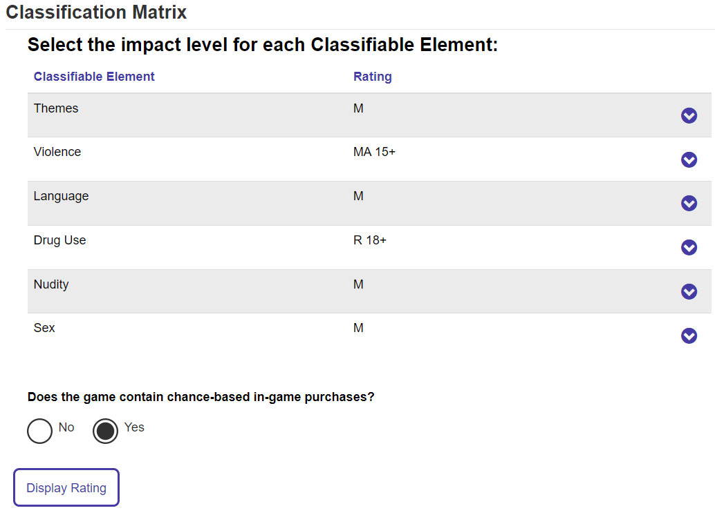

If you have incorrectly indicated “No” to Chance-based in-game purchases and selected **Display Rating,** the following steps must be followed in order to make chance-based in-game purchase consumer advice terms appear on the next page:

* + 1. Select “Yes” to “Does the game contain chance-based in-game purchases”.
    2. Temporarily change the rating of one of the classifiable elements to a different rating. (e.g. change ‘Sex’ to G classification).
    3. Select ‘Display rating’.
    4. Change back the rating of the classifiable element you changed in step ii to the correct rating. (e.g. change ‘Sex’ back to the correct M classification).
    5. Then, go to step 13.

1. Select **Display Rating** to generate the overall rating. The overall rating corresponds with the highest rated element(s).

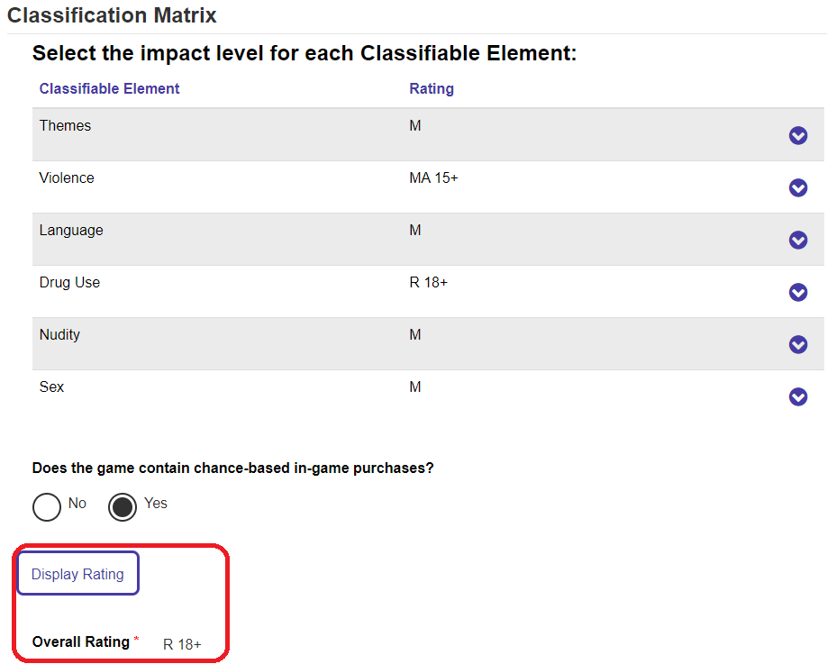

1. In **Reason(s) for decision**, input text for both questions. Then select **Save and next**.
   1. Please input brief details or examples of the classifiable element(s) you identified with the highest impact within the computer game. You can provide timestamps, as relevant.

*Example: The game contains a breakdown of a familial relationship as well as adolescent behaviour related to risk-taking and questioning sexuality. In chapter 2 of the main story, a child is depicted witnessing a verbally abusive argument between their parents. The game contain use of the word ‘f**k’ throughout.*

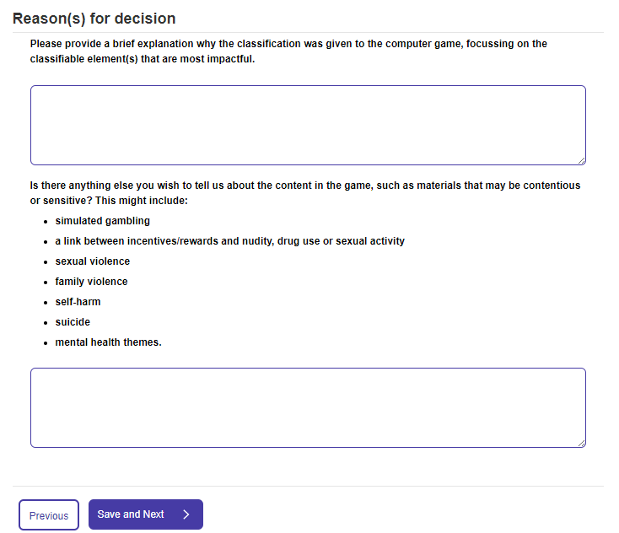

* 1. Please input brief details or examples of contentious or sensitive content present in the game, if any.

*Example: In chapter 3 of the main story, a teenager references that their father is violent towards their mother. There is simulated gambling present as players can play slots in a casino.*



### Consumer Advice

The consumer advice (CA) section of the submission uses logic based on the ratings for each element you selected at Step 12. The form will only display the elements and consumer advice terms that may be applicable at the overall rating of the computer game, or one lower for any issues of community concern. If you selected “Yes” to the presence of chance-based in-game purchases, chance-based in-game purchase consumer advice terms will also appear under Themes when Themes is a minimum of M.

If an element or consumer advice term does not appear on the list, it is because it does not meet the logic for inclusion in the consumer advice or the term is not on the current consumer advice list issued under section 12A of the *Classification (Publications, Films and Computer Games) Act 199*5.

1. Select **Add/Remove CA Terms** to add consumer advice terms for each classifiable element, select the applicable terms using the tick boxes, and then select **Add CA terms**. There may be a scroll bar on the right-hand side. Use the scroll bar to view additional consumer advice terms and the **Add CA Terms** button.
   1. Consumer advice terms are **mandatory** for elements corresponding with the overall rating.
   2. Consumer advice terms are **optional** for elements that are one rating lower than the overall rating.  
      If relevant, input only the issues of community concern present in the game at one rating lower.
   3. Consumer advice terms for chance-based in-game purchases are **mandatory** if you selected “Yes” to the question “Does the game contain chance-based in-game purchases?”.

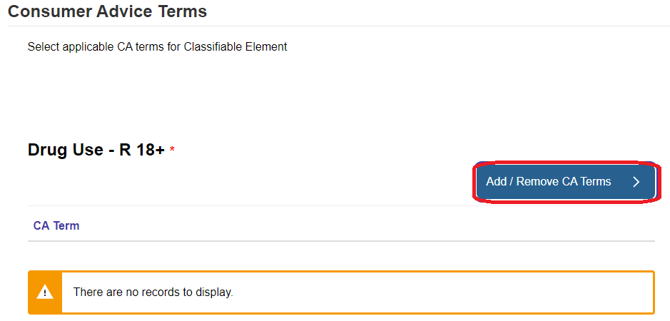

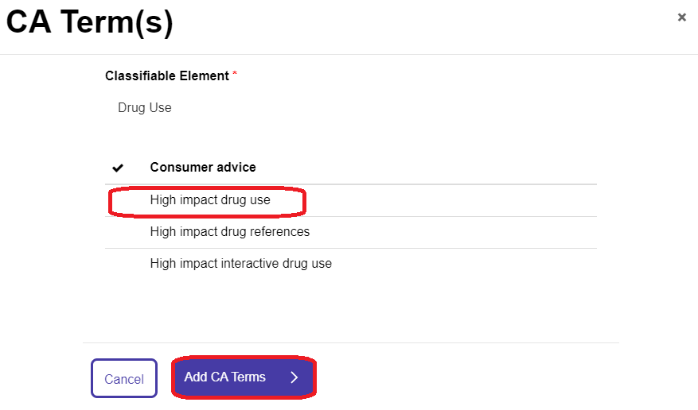

1. After selecting the consumer advice terms you need, select ‘Display Consumer Advice’. The system will then generate the overall consumer advice.
   1. If the overall consumer advice reflects your classification decision, select ‘Save and Next’.
   2. If the overall consumer advice does not reflect your classification decision, please select the correct consumer advice terms in the relevant classifiable elements and if needed, go to the previous page and change the classification matrix.

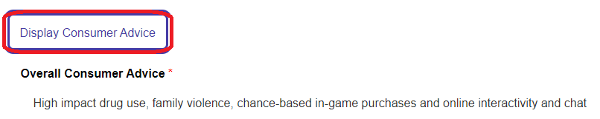

### Upload media

1. You can upload or provide links to media, and then select **Save and Next.**

These options are available to you:

* **online via Box** – upload media files directly to Box (file size limited to 3GB).
* **online via another method** – enter the location or file path, including relevant access code or password in the text box. Please advise if the link is only available for a specified period .
* **a physical copy of the content** – if you are posting a DCP drive or other physical media via a courier.

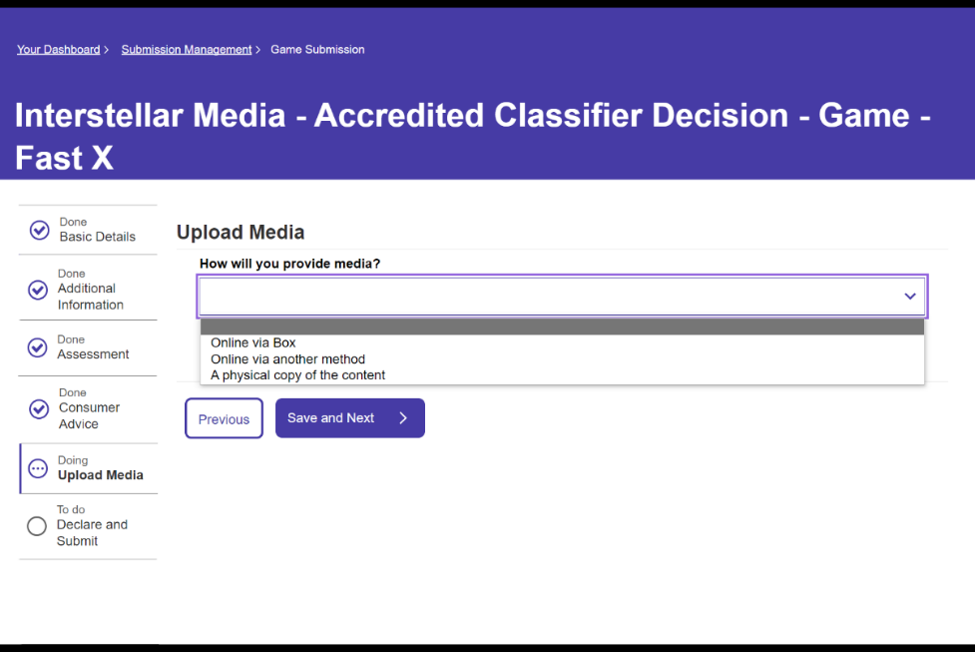

### Declare and submit

1. Select **Download Summary** if you would like to download a copy of the submission.

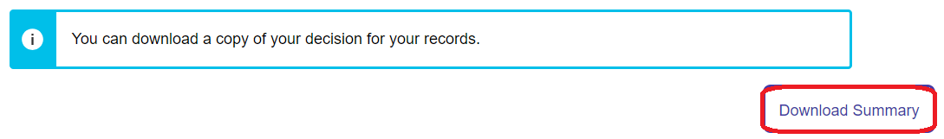

1. Review the “**Your classification decision**” section to check that the overall rating and consumer advice reflects your classification decision.

If it does not correctly reflect your decision, please use the ‘Previous’ button at the bottom of the page to return to previous pages.

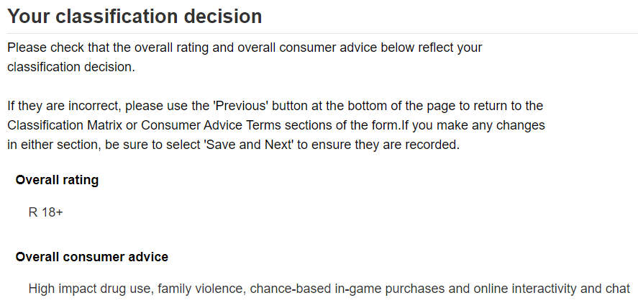

1. Review the declaration, select the tick boxes to agree, then select **Submit**.

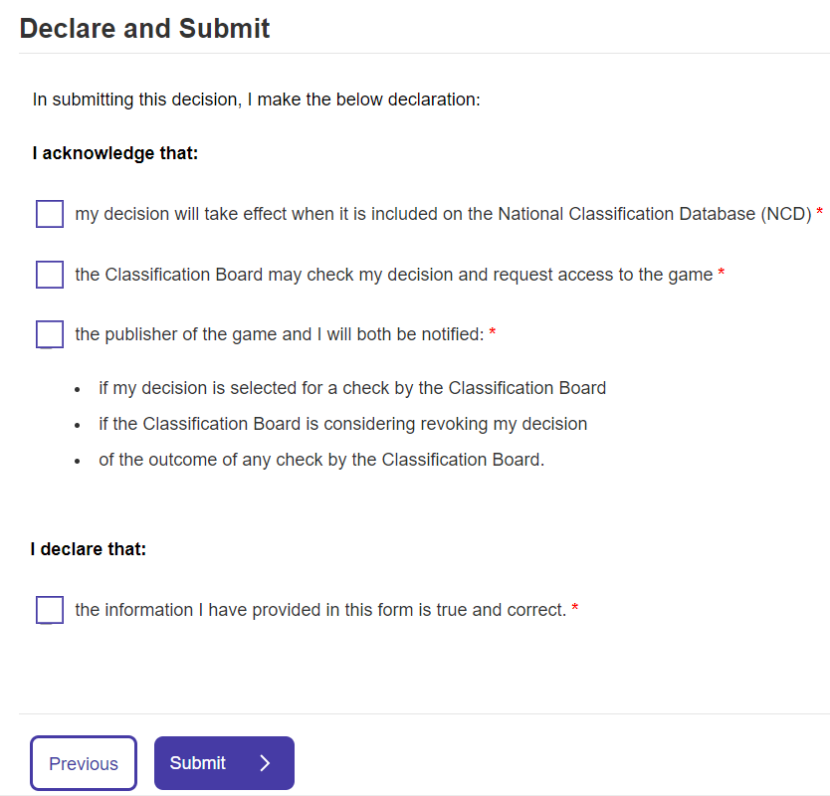

# After submission

The classification decision takes effect under the Classification Act when it is included in the National Classification Database at [classification.gov.au](https://classification.gov.au).

If you have made an error in the submission, please email [accreditedclassifier@infrastructure.gov.au](mailto:accreditedclassifier@infrastructure.gov.au). The department will notify you of the next steps.