 

Applications Portal – User Guide

How to use the Portal

November 2022 (V1.0)

**Contents**

Introduction 1

Summary of User Guides and other support materials 2

Logging on 2

The Main Dashboard 2

Notifications 5

Core Data Entry Techniques 5

Basic Form Navigation and Data Entry 5

Adding entries in a list (Directors, Producers etc) 6

Removing/Editing/Taking an action on entries in a list (Directors, Producers, Obtain Certificates, for example) 8

Use of the Magnifying Glass – another way to reveal a list of items for selection 9

Selecting pre-defined items from a large list 10

Searching for a previous decision 11

# 

## Introduction

This is a general guide that helps you know how to navigate around the Portal and enter data.

The Portal supports a range of data types and this guide will be useful as you come across these in the system.

## Summary of User Guides and other support materials

We are looking forward to receiving feedback on what is needed by Industry in understanding how to use the portal and will continually update this and other support materials.

Current support materials include:

* This guide – for guidance of general navigation and data entry
* Frequently Asked Questions or FAQs
* Specific guides on:
  + Organisational and Financial Management
  + CTW and Contentious material
* A reference guide that documents key pathways in the system and the data to be entered. This is a larger document and useful when you want to search on a particular topic.

## Logging on

Login is via use of an Email address, password and entry of a one-time code sent to your mobile phone.

A “forgot” password link is available.

If you change your mobile number without updating the Portal, you will need to contact the Applications team and they will help.

Note that every time you logon, you are acknowledging the following statement:

**By continuing to use this Portal, you have confirmed you have read and agreed to the Portal Terms and Conditions**

## The Main Dashboard

The dashboard is the first screen displayed after logging on and provides 3 large panels which you can click on to progress into the area indicated.

The 4 areas are:

* **Event management** – for all events other than those needing 6H exemptions. For 6H Events, please contact the Applications Team.

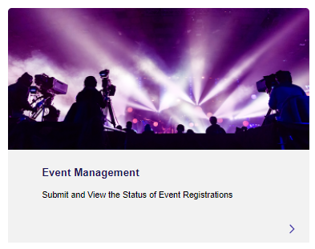

* **Applications Management –** for allcontent applications – Film, Games and Publications.
  + The Portal will lead you down pathways according to the type of content you are submitting and key aspects such as if the content has been classified before.
    - All application types (ACAs, ATSAs, PEs, FOs) are in here and the Reference Guide provides full details on these pathways.



* **Organisation Management –** management of users associated with organisations and visibility on balances and financial transactions are in here.
  + The Organisational and Financial Management Guide has everything you need to understand this section.

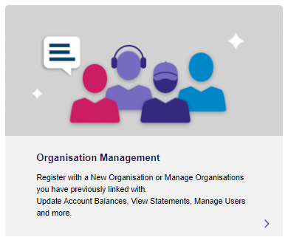

* 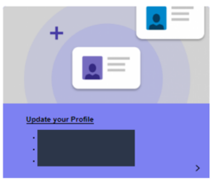**Update your Profile** – email for logon, phone number, email for notifications, email for learnhub and visibility of training completed. You can also update your links to multiple organisations here.

There are also two places where you’ll find notifications – in the top Welcome bar and also a bell shaped icon in the upper right of the dashboard.

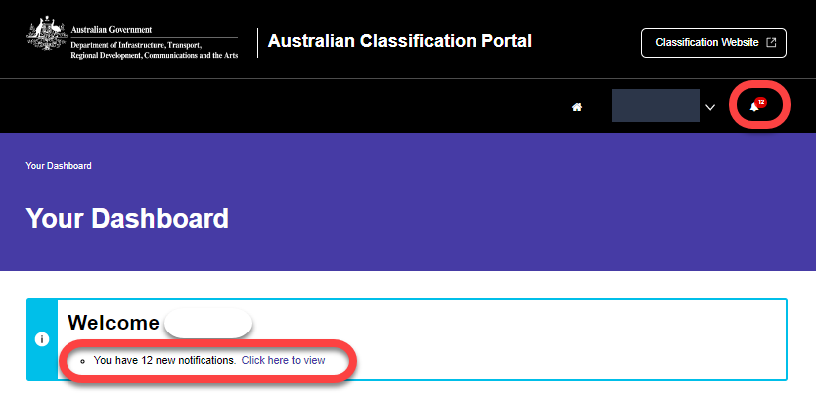

### Notifications

The Portal supports a range of notifications – including: providing updates on the status of your application, payment confirmations and addition to a new organisation.

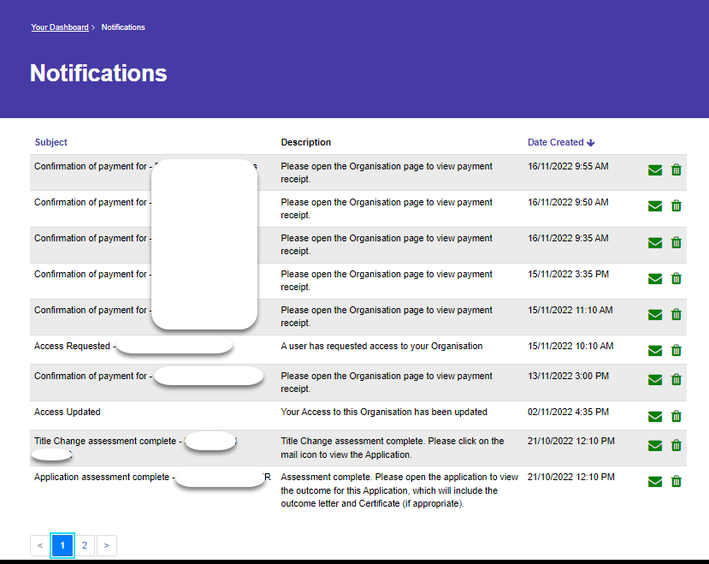

Click on the letter icon to go the relevant list.

Click on the bin icon to delete the notification.

## Core Data Entry Techniques

### Basic Form Navigation and Data Entry

When faced with a form like the one below, click on the downward facing chevron and all data entry fields available under the item will be displayed:

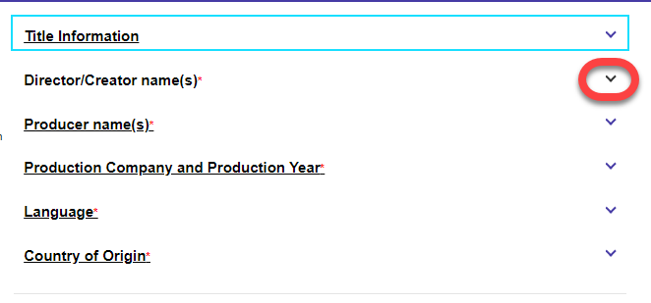

Once you have completed the data entry in one item, click on more downward facing chevrons until you have entered all necessary data.

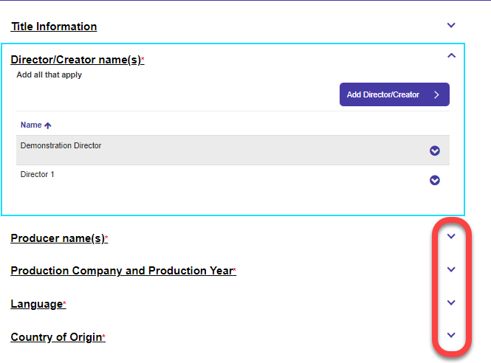

Mandatory fields are highlighted with a red “*” symbol. If you have missed a mandatory field, the system will display an error and prevent you moving to the next form until it is filled in.

### Adding entries in a list (Directors, Producers etc)

When creating applications, you often need to enter multiple names or entries for an item. Following the example of adding multiple Directors, the steps are:

**Step 1**

Click on the downward facing chevron to the right of the title text:



**Step 2**

Click on the “Add <name of item>” button:

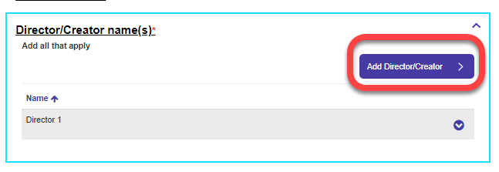

**Step 3**

Enter the details in the field(s) provided and press the “Add <name of item>” button:

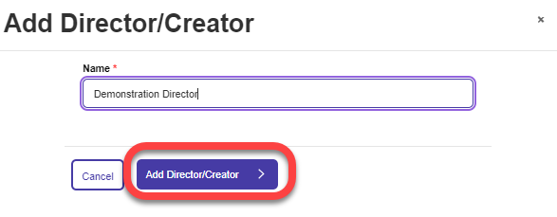

Your items will be displayed as follows and you can add more or go to the next field for data entry.

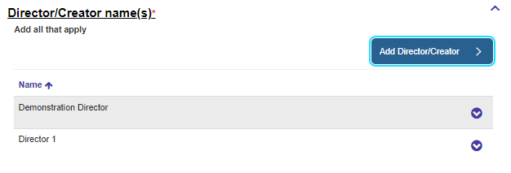

### Removing/Editing/Taking an action on entries in a list (Directors, Producers, Obtain Certificates, for example)

If needed, you can also remove or edit items from the list – just click on the downwards facing chevron to the right of the item name and options will be available (in this case, the only option is to Remove the item):

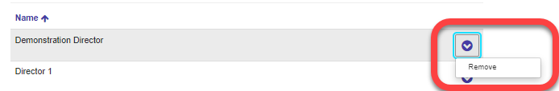

In general, look out for these downward facing chevrons, as they contain options relevant to the list at the time.

Here is an example of the list of applications and the ability to edit, remove or download a draft application:

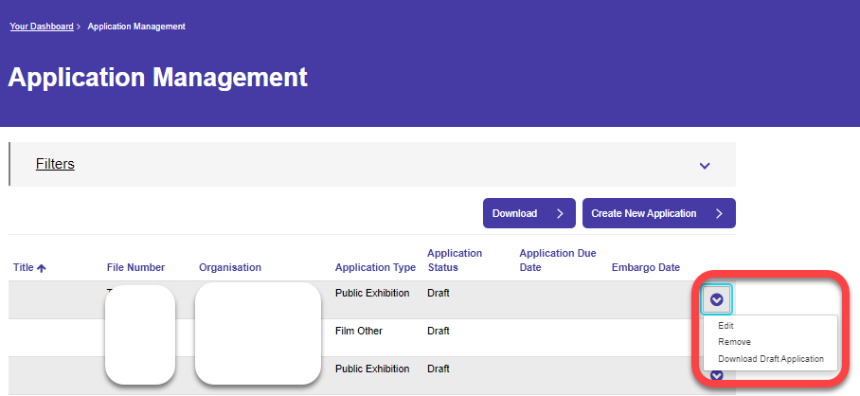

‘

..and here is what you can do with a finalised application – download your Classification Certificate here!

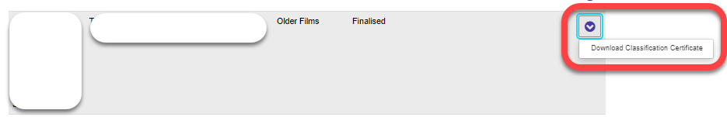

### Use of the Magnifying Glass – another way to reveal a list of items for selection

In some cases you can’t enter data directly into the field as shown. In these cases, there will either be a button to press or a magnifying glass to take you to the next step.

Here is an example of selecting an “Impact” in a Recommendation item and, in this case, click on the Magnifying glass to the right of the field:

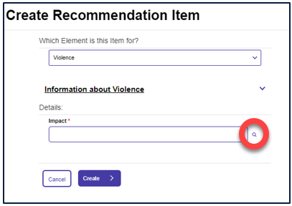

..and here is another example – selection of a Document Type:

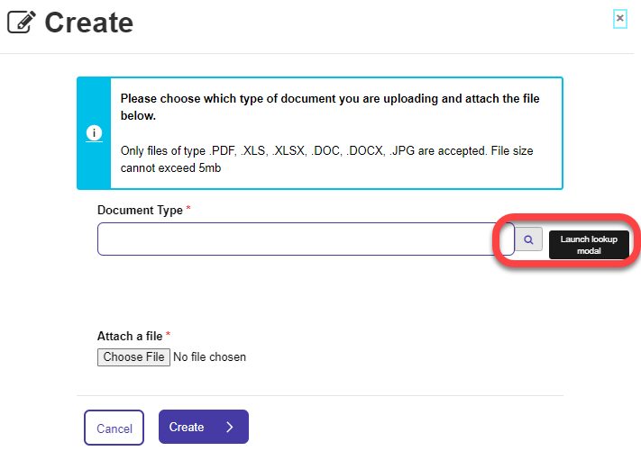

### Selecting pre-defined items from a large list

Here is an example of a range of pre-defined data entry options (Countries example):

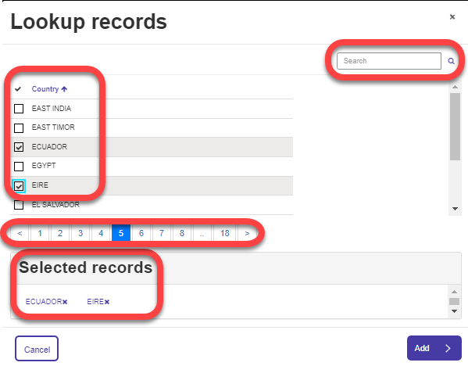

Key things to note are

* Click on each item that you want to add from the main list
  + A tick will appear in the box to the left for each item and it will be added to the “Selected Records” area.
* If you’ve added an item you don’t want, just click the “x” symbol next to the item in the “Selected Records” area.
* If there are lots of entries (as shown – over 18 pages) – use the Search field in the top right to filter down the items shown.
  + The wildcard character “*” can be used here.
* To clear your search items, just delete all characters in the search field and press “Enter”.
* When finished adding all your items, click the “Add” button on the lower right.

### Searching for a previous decision

There is one particular aspect to note when searching for a previous decision

**Step 1**

If you have chosen “My application is for a new version of something that is previously classified” from the menu below:

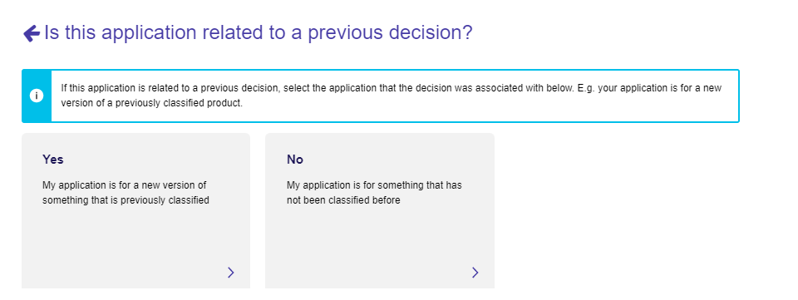

You then have the following form:

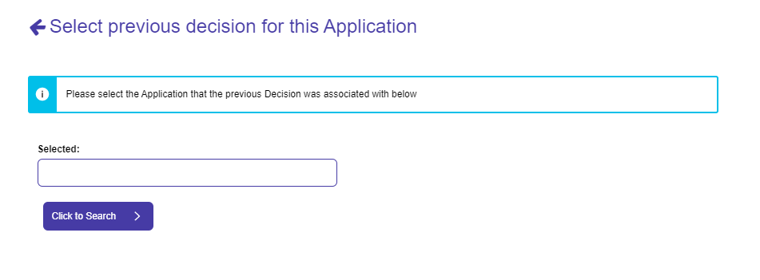

Note that you can’t enter data into the “Selected” field shown - click the “Click to Search” button” to search for the relevant application.

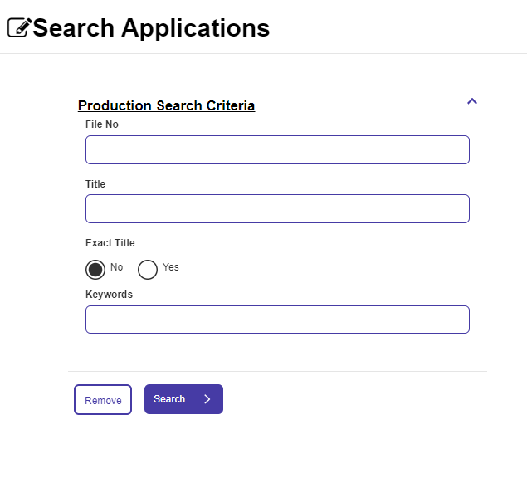

Search by: File number, Title (exact title yes/no) or keywords and press “Search”.

Note that I’ve clicked and selected “Smurf’s Easter Special” below but the only button apparently available is the “Close” button:

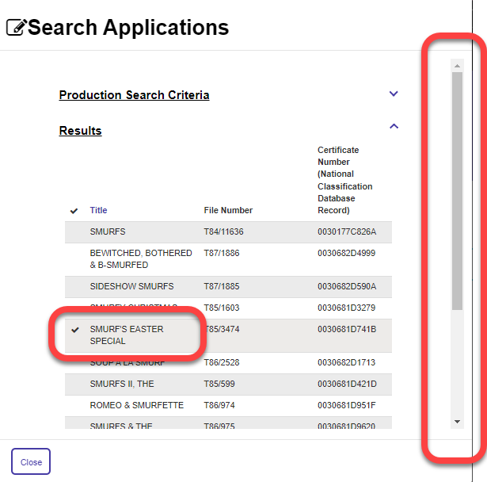

To get to the “Select” button in this case – you need to use the scroll bar on the right hand side and pull it down:

