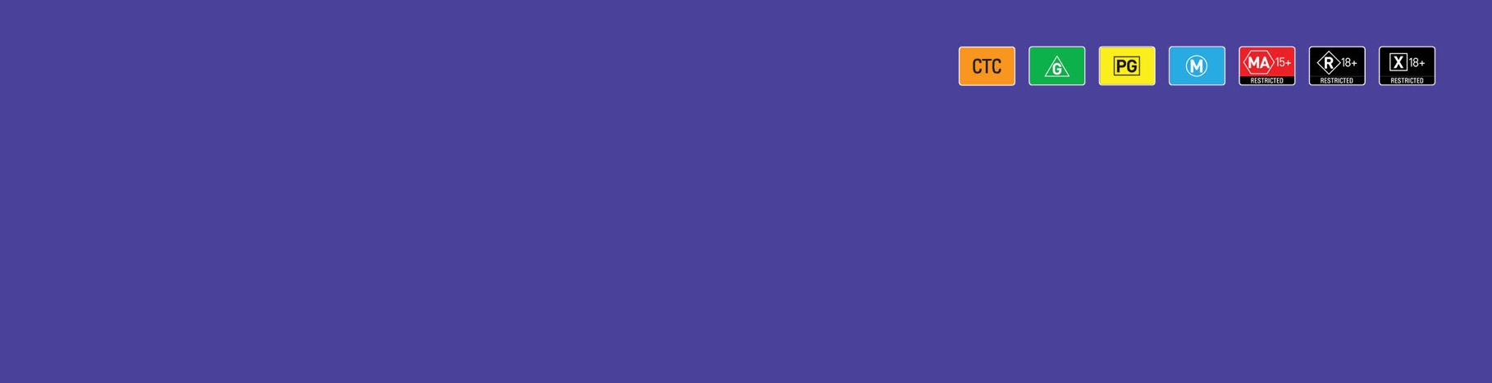 

User Guide

Accessing notices for a Classification Board check   
of an accredited classifier decision

March 2024

# Introduction

The Classification Board may revoke and replace an accredited classifier decision under section 22L of the *Classification (Publications, Films and Computer Games) Act 1995* (Classification Act).

The process by which the Classification Board determines if they are of the view that the classification (rating) and/or consumer advice should be different, is by checking the decision made by the accredited classifier.

The Classification Board’s process is:

* issue the accredited classifier and the publisher a **Board Check Notice** in the Classification Portal (Portal)
* view the film or the gameplay footage
* come to a preliminary view that agrees with the decision, and issues the accredited classifier and the publisher a **Board Agrees Notice** in the Portal, or
* come to a preliminary view that is different to the decision, and issues the accredited classifier and the publisher a **Notice of Possible Revocation** in the Portal.

If the Classification Board issues a **Notice of Possible Revocation**, it will invite the accredited classifier to make a submission in 7 days as to why the Classification Board should not revoke the decision.

Following the 7-day period in which to make a submission, the Classification Board can either:

* finalise their preliminary view and revoke the classifier’s decision, and issue a **Revocation Notice** in the Portal, or
* determine the classifier’s decision remains in effect, and issue a **Board Agrees Notice** in the Portal.

This user guide is for accessing the notices the Classification Board issues during the check process in the Portal.

To learn more, go to [classification.gov.au/for-industry/accredited-classifiers](http://www.classification.gov.au/for-industry/accredited-classifiers).

# Receiving a Portal notification

The accredited classifier and publisher of the film/game undergoing a check will receive notifications:

* via an email to the address registered to the Portal account, advising you have a notification in the Portal.
* upon log in to the Portal, a message will appear on **Your Dashboard** with a link.
* a red speech bubble will appear on the bell icon in the top right-hand corner.

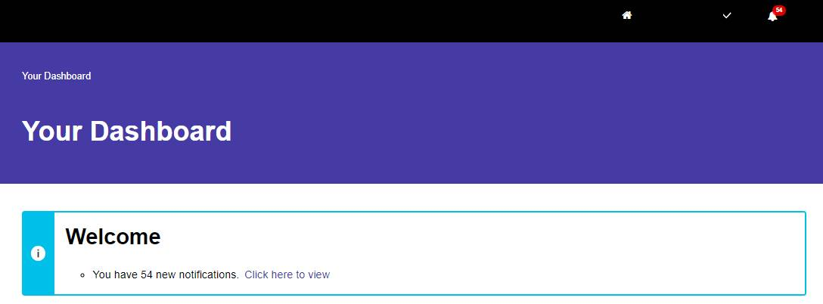

# Accessing notices

1. Find the decision. The application status for the decision will update to **Finalised – Undergoing Board Check.** Select the chevron to download the relevant notice.

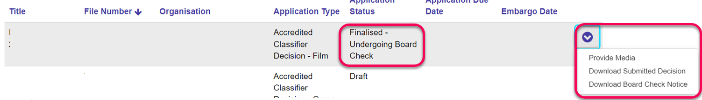

### Board Check Notice

1. Review the notice, and take relevant action.
2. If you did not provide the content with the submission, you can upload it in response to the notice using **Provide Media.** Any delay in providing the media will delay the Classification Board’s preliminary view.

### Board Agrees Notice

1. Review the notice. You do not need to take any further action.

### Notice of Possible Revocation

1. Review the notice.
   1. If you choose to make a submission, follow the instructions in the **Notice of Possible Revocation**.
   2. You may also **Provide Media** to provide any content to support your submission.

### Revocation Notice

1. Review the notice, and take required action to display the updated classification markings.