

FINAL REPORT

ON THE PUBLIC CONSULTATION
ON THE POSSIBLE INTRODUCTION OF AN
R 18+ CLASSIFICATION FOR COMPUTER GAMES

November 2010

NOTE: This consultation was not intended to promote or oppose the introduction of an R 18+ classification for computer games, but rather gather community views. It does not indicate that any Minister or Government does or does not support introducing an R 18+ classification for computer games.

© Commonwealth of Australia 2010. This work is copyright. You may download, display, print and reproduce this material in unaltered form only (retaining this notice) for your personal, non-commercial use or use within your organisation. Apart from any use as permitted under the Copyright Act 1968, all other rights are reserved. Requests and inquiries concerning reproduction and rights should be addressed to Commonwealth Copyright Administration, Attorney General’s Department, 3-5 National Circuit, Barton ACT 2600 or posted at http://www.ag.gov.au/cca

Table of contents
Background 4
All submissions 6
Submissions from individuals 7
Format 8
Age 9
Gender 10
Frequency and length of game play 11
Supporting and opposing arguments 12
Comments 14
Submissions from organisations / groups 15
Has the lack of an R 18+ classification resulted in the under-classification of computer games in Australia? 15
Does violence in games influence real life violence? 16
Should there be international parity of classification schemes? 17
Priorities of the National Classification Principles 18
Changing nature of the computer gaming market and industry 19
The interactivity of games 20
Enforcement of age restrictions by parents 20
Depictions of women, children and religion in R 18+ games 21
Challenges presented by the convergence of technologies 22
List of groups / organisations and their response 23

Background
In Australia, the availability of films, computer games and some publications is regulated by the National Classification Scheme (NCS). The NCS is a cooperative arrangement between the Commonwealth, States and Territories.
The NCS consists of the Commonwealth Classification (Publications, Films and Computer Games) Act 1995 (the Act), the National Classification Code 2005 (the Code) and the Guidelines for the Classification of Films and Computer Games (the Guidelines). The Act, the Code and the Guidelines create a sliding scale of classification categories for publications, films and computer games.
Any change to the classification categories requires amendments to the NCS, the Act, the Code and the Guidelines, as well as State and Territory enforcement legislation. Under the Act and the Intergovernmental Agreement on Censorship, the Code and the Guidelines can only be amended with the agreement of all Commonwealth, State and Territory Ministers responsible for censorship.
The highest classification level for computer games is Mature Accompanied (MA 15+). MA 15+ games are not recommended for persons under 15 years of age and are in a legally restricted category.
Computer games that are unsuitable for a person under 15 to see, must therefore be classified Refused Classification (RC). These games may not be sold, hired, exhibited, displayed, demonstrated or advertised in Australia.
Discussion paper
On 14 December 2009, the Minister for Home Affairs, the Hon Brendan O'Connor MP, released the discussion paper Should the Australian National Classification Scheme include an R 18+ classification category for computer games?
Submissions formally closed on 28 February 2010. The Commonwealth Attorney-General’s Department received 59,629 submissions via email, fax, post, and from the retailer EB Games and from the organisation ‘Grow Up Australia’.
Final report
This report contains the final figures from the public consultation. Changes in figures between the status report and the final report are largely caused by the removal of duplicate and invalid submissions.

The Commonwealth Attorney-General’s Department received 58,437 valid submissions. Below are the final results, with the overall result and a breakdown of individual submissions by State and Territory, the format in which submissions were received, age, gender, the frequency and length of game play, responses to the supporting and opposing arguments and free text comments. There is also an overview of submissions made by organisations and community groups.
This report does not reflect the views of Ministers on the issue of whether the NCS should include an R 18+ classification category for computer games. Ministers will continue to deliberate on this issue.
Further information
Please send advice of any errors or omissions to classificationpolicysection@ag.gov.au.
The final report, discussion paper, stakeholder submissions and samples of submissions received from individuals are available on the Commonwealth Attorney-General’s Department website at <www.ag.gov.au/gamesclassification>.
Further information on the National Classification Scheme and links to the Act, the Code and the Guidelines are available at <www.ag.gov.au/classificationpolicy>.

All submissions
Respondents to the discussion paper were asked to answer the following question:
Should the Australian National Classification Scheme include an R 18+ classification category for computer games?
Final figures show that out of a total of 58,437 individual and group submissions 98%, (57,500), of submissions supported the introduction of an R 18+ classification for computer games, while 2% (937), opposed.

Figure 1. Overall responses
The figures below show the format in which all submissions were received by the Commonwealth Attorney-General’s Department.
Figure 1. Overall submissions by format
Figure 2. Overall responses by format

Submissions from individuals
Final figures for individual submissions show that out of a total of 58,403 submissions 98%, (57,482), of submissions supported the introduction of an R 18+ classification for computer games, while 2% (921), opposed.

Figure 3. Responses from individual submissions

All submissions from the community were accepted regardless of whether all fields in the discussion paper template were completed. The following data reflects the fields within the submissions that were completed. For example, if a submission provided age details but not gender, the age details are shown in the data, but the gender details are not. As a result, the totals provided in the following figures will not add up to the total number of submissions.
The majority of submissions were from respondents in New South Wales, Queensland and Victoria.

Figure 4. Submissions by jurisdiction
Format
Submissions were received via email, fax and post. While most submissions made use of the submission template released with the discussion paper, some submissions (both those supportive of an R 18+ classification for computer games and those opposed to such a classification) did not follow this template. All submissions were accepted.
The majority of submissions received in a non-template hardcopy were from the games retailer EB Games (34,210 total: 4092 of these included individual comments while 30,118 provided no additional comments). This was followed by submissions that followed the template collated by the organisation Grow Up Australia (15,701), with many of these providing additional comments.
The remaining submissions were sent directly to the Commonwealth Attorney-General’s Department. The majority were received via email (7162), followed by post (758) and fax (572). Many of these also contained individual comments. The Department received 34 submissions with detailed comments from community, church and industry groups (see p 15).
Figure 5. Submissions by format

Age
The majority of respondents were in the age category 18-24 years (26,712), followed by 25-34 years (15,566), under 18 years (7253) and 35-44 years (5410).
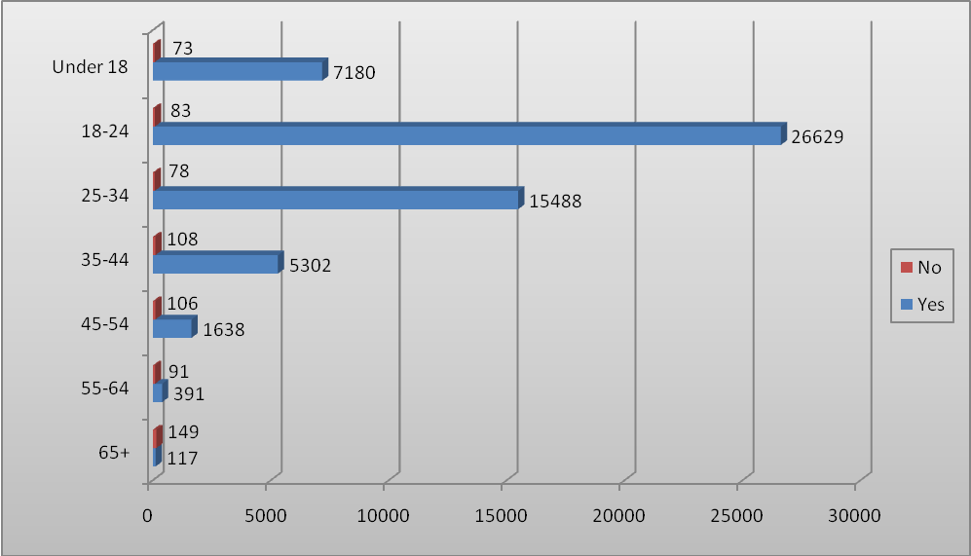
Figure 6. All submissions by age

The figures below show supporting and opposing submissions by age category. The age of respondents who supported an R 18+ classification mirrors the overall age results. The age of respondents who opposed an R 18+ classification is more evenly spread, with the majority in the age category 65+ years (149), followed by 35-44 years (108) and 45-54 years (106).
Figure 7. “Yes” submissions by age
Figure 8. “No” submissions by age

Gender
The majority of respondents were male (48,226 male and 9510 female).

Figure 9. Submissions by gender

The figures below show supporting and opposing submissions by gender. The majority of respondents who supported an R 18+ classification were male, 47,808 (84%) with 9176 females in support (16%). The majority of respondents who opposed an R 18+ classification were also male, 418 (57%) with 320 females opposing (44%).
Figure 10. “Yes” submissions by gender
Figure 11. “No” submissions by gender

Frequency and length of game play
Respondents were asked whether they played computer games, and if so how frequently and for how long. Final results showed that the majority of respondents who played computer games did so on a daily basis (35,617), followed by weekly (16,039), fortnightly (1833) and monthly (1474). 1223 respondents stated they had never played computer games.

Figure 12. Submissions by frequency of play
Final results also showed that the majority of respondents who played computer games did so for over 2 hours (21,526), followed by 1-2 hours (19,743), 30-60 minutes (12,772), 15-30 minutes (2857) and 0-15 minutes (463).
Figure 13. Submissions by average play session

Supporting and opposing arguments
The submission template presented a range of arguments in support or opposition to the introduction of an R 18+ classification for computer games. Respondents were asked to indicate how strongly they agreed / disagreed with these arguments by circling one of the following options: ‘strongly disagree,’ ‘disagree,’ ‘do not know,’ ‘agree’ or ‘strongly agree.’
Please note that these figures do not include submissions collected by EB Games, as those submissions did not answer these questions.
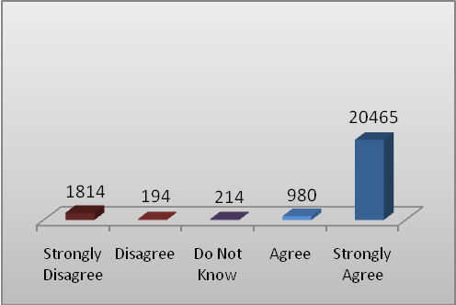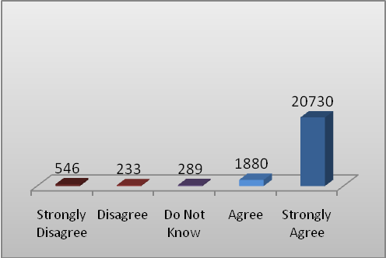
Adults should not be prevented from playing R 18+ level computer games simply because they are unsuitable for minors.
The R 18+ classification category sends a clear, unambiguous message to parents that the game material is
unsuitable for minors.
Figure 14.
Figure 15.

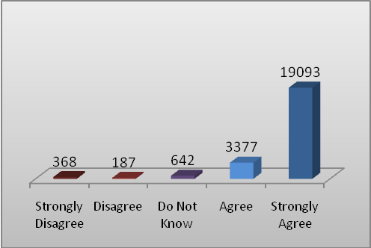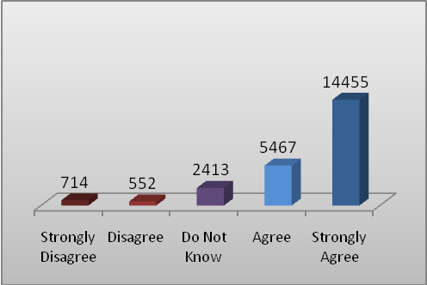
Consistent classification categories for films and computer games are
easier to understand.
A new classification will supplement technological controls on minors’
access to age inappropriate
computer games.
Figure 16.
Figure 17.

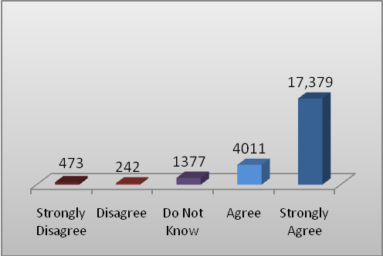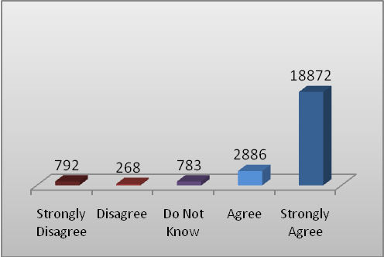
Comparable classification systems internationally have an adult rating for computer games - international
parity is desirable.
Consumers access games which would be R 18+ illegally – it would be better if they were legally available with
appropriate restrictions.
Figure 18.
Figure 19.
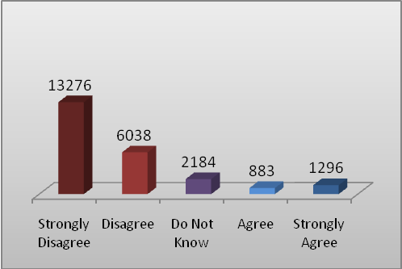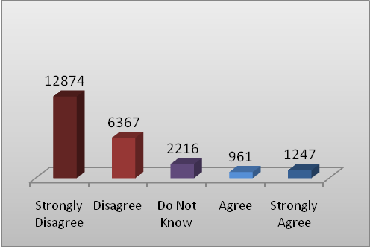
It would be difficult for parents to enforce age restrictions for computer games.
Minors would be more likely to be exposed to computer games that are unsuitable for them.
Figure 20.
Figure 21.

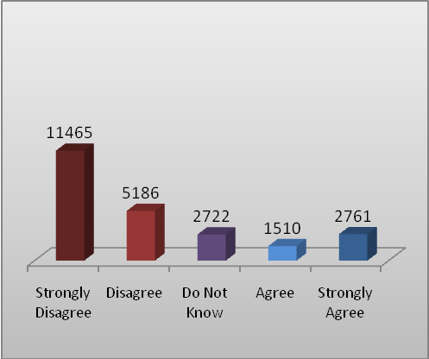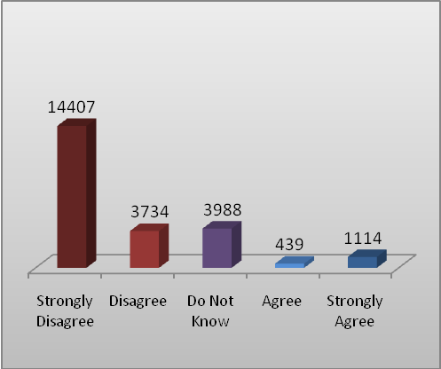
Computer games should be treated differently from films given the specific, negative effects of interactivity on players, particularly their
participation in violent and aggressive content.
An R 18+ for computer games would exacerbate problems associated with access to high level
material in Indigenous communities and by other
non-English speaking people.
Figure 22.
Figure 23.

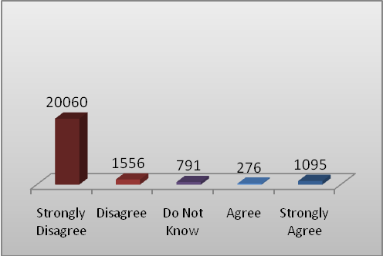
There is no demonstrated need to change
existing restrictions.
Figure 24.

Comments
The submission template also provided a ‘free text’ option where individuals were invited to write up to 250 words to expand upon their submission. Comments that were frequently made and the number of submissions supporting them are included below. This data does not include comments in submissions from Grow Up Australia.
The lack of an R 18+ classification means that the Australian classification categories are inconsistent with the rest of the world.
There is an inconsistency between the classification categories of films and computer games.
Computer games are now an adult form of entertainment and the average age of a gamer is over 18.
Because of the lack of an R 18+ classification, the Board stretches the limits of the MA 15+ classification category to allow R 18+ material.
Young people are accessing games that their parent should not allow anyway.
A lack of an R 18+ classification for computer games restricts the civil liberties of adult gamers.
The games which are classified Refused Classification in Australia can be bought overseas and imported.
The lack of an R 18+ classification for computer games has a negative impact on the Australian computer games industry.
The requirement for unanimous agreement by all Censorship Ministers to introduce an R 18+ classification for computer games is too stringent.
What content children access is a parent/guardian responsibility.
Playing violent computer games is a stress relief.
R 18+ games would be too violent.
An R 18+ rating will provide more guidance to parents.
An 18+ restriction exists for other adult activities. Games should not be singled out.
There is a lack of evidence that games are harmful to society.

The games that are currently classified Refused Classification in Australia can be downloaded online.

Games are more interactive than films.
Figure 25. Common free text comments
Submissions from organisations / groups
The Department received 34 submissions from community, church and industry groups. Of these, 18 (53%) supported the introduction of an R 18+ classification for computer games while 16 (47%) opposed its introduction. Two organisations requested confidentiality for their submissions. A list of the names of the other organisations and their support or opposition is listed at the end of this report (p 23).

Figure 26. Submissions from groups / organisations

The arguments raised by these organisations are discussed below. This analysis does not cover all arguments made by all organisations. The submissions made by groups and organisations are available on the Attorney-General’s Department website at: <www.ag.gov.au/gamesclassification>.
Has the lack of an R 18+ classification resulted in the under-classification of computer games in Australia?
The highest classification currently available for computer games in Australia is MA 15+. Does the lack of an R 18+ classification in Australia lead to an under-classification of computer games that have been restricted to persons over 18 in other countries? Do the differing criteria for classifying computer games MA 15+ and RC (Refused Classification) in Australia and 18+ and other classifications in overseas jurisdictions make direct comparisons difficult?
For an R 18+ classification
The Communications, Entertainment & Technology Law Committee of NSW Young Lawyers (CET) and Electronic Frontiers Australia and AusGamers (EFAA) argue that there is a continuing trend to classify computer games as MA 15+ in Australia and that these same games are restricted to adult only sales and use in other overseas markets such as the USA, UK, NZ and the EU. They allege that, in Australia, these games are under-classified, falling into categories that are inappropriate. They argue that under-classification creates a higher chance of minors accessing unsuitable material than they would under a system with an R 18+ classification. They suggest that some parents may allow their children to play MA 15+ games despite being under 15 because they feel their child is mature enough, or they do not know the full extent of the game’s mature content, or because their children pressure them. EFAA argue that parents would be less likely to ignore the classification and allow their children to access an R 18+ game if such a classification was introduced.
EFAA provided a list of 91 titles that they claim the Australian Classification Board classified MA 15+ or RC in 2009. Of these EFAA found that where a game had been classified in the USA, UK and EU member countries, 24 titles were classified as being unsuitable for minors and restricted to 18 years or over. CET provided a number of other examples that they argued support the proposition that adult games are under-classified as MA 15+. CET also argues that the minimal descriptions given to MA 15+ rated games do not give parents enough guidance and information.
Against an R 18+ classification
The Australian Council on Children and the Media (ACCM) argues that some potentially R 18+ games have had content deleted in order to meet the MA 15+ guidelines. ACCM argues that, if high impact material is being ‘squeezed’ into the MA 15+ classification, this is an argument for stricter classification, not for legalising the R 18+ category.
Does violence in games influence real life violence?
There is no clear consensus on any correlation between violent computer games and real life violence.
For an R 18+ classification
Interactive Games & Entertainment Association Ltd (iGEA), Media Classifiers’ Association of Australia (MCAA), XLAN Inc (XLAN) and EFAA argue that there is a lack of conclusive scientific evidence that violent media causes or triggers violent behaviour. These submissions pointed to Australian and overseas government funded reports and inquiries that suggest there was no direct causal link between exposure to violent media and violent behaviour.
They also argue that there is no evidence to suggest that violence in video games is more damaging than violence in films and other media. Australian Computer Society (ACS) and iGEA also claim that the lack of an R 18+ classification will not stop minors from accessing adult material illegally online, through friends or through other forms of media. ACS and iGEA argued that research supporting a link between simulated violence and aggressive behaviour has come from limited sources and questionable experimental practices. Telstra suggests that the lack of scientific consensus on the issue highlights the need for more research to be done; however, it is still in support of the introduction of an R 18+ classification.
Against an R 18+ Classification
The Sporting Shooters Association of Australia (SSAA), certain members of WA Parliament (WA Parliamentarians), FamilyVoice Australia (FAVA), Commissioner for Children Tasmania (CCT), Commissioners for Children and Young People and Child Guardians (CCYPCG) and the ACCM presented research that points to violence in video games as a source of aggressive and anti-social behaviour amongst game players. For example, ACCM argues that the evidence of the harm caused by violent video games in particular is clear and damaging. Recent research by Dr Douglas Gentile and Professor Craig Anderson is cited.
These groups have several concerns about the flow on effects of video game violence. The CCYPCG expressed concerns at the immediate effects of simulated violence on children. These concerns centre on academic underperformance, juvenile delinquency and increased aggression.
SSAA, CCYPCG and the Australian Family Association (WA Branch) (AFAWA) argue that simulated violence could negatively affect people with mental illnesses, antisocial personality types and other vulnerable groups.
SSAA is concerned that the rights of recreational shooters would be further limited should another serious crime involving firearms be carried out by those who had been affected by video game violence.
Should there be international parity of classification schemes?
Australia is unique among developed countries that have a classification scheme for computer games (either government regulated or industry self-regulated) because it does not have a classification category that is restricted to adults.
For an R 18+ classification
Many groups supportive of an R 18+ classification argue that it is desirable for Australia’s classification system to operate in line with other international systems. EFAA states that Australia is the only liberal democracy not to recognise the expressive potential of adult video games. EFAA compares Australia with comparable countries – including the UK, EU member countries, the USA and NZ – which all include an adult classification for computer games. CET and the Australian Democrats (ACT Division) (ADACT) argue that alignment would be seen as a sign of positive international cooperation, an important step to preventing under-classification and an effective way to address the issue of illegal overseas access.
CET, iGEA, ACS and XLAN argue that consumers can, and do, contravene classification laws to import or download legal or illegal copies of games that have either been classified RC or have been modified to meet the MA 15+ classification. They argue this circumvention is damaging to retailers and game developers in Australia. They further argue that Australian retailers are disadvantaged as they are not able to access a closed market and the gaming industry as a whole experiences the loss of profits from piracy. They suggest that bringing in international parity will also open up a creative and economic market for Australian game developers.
Against an R 18+ classification
AFAWA argues that Australia should not have to introduce an R 18+ classification simply because other developed countries have. ACCM argues that the classification schemes differ between developed countries for reasons of cultural difference and different bases for legal systems.
Priorities of the National Classification Principles
The classification principles set out in the National Classification Code include:
- Adults should be able to read, see and hear what they want; and
- Minors should be protected from material likely to harm or disturb them.
For an R 18+ classification
ADACT, XLAN, The Older Gamers (TOG), iGEA and the MCAA argue that it is possible to find a solution that balances both principles equally. The iGEA and the Australian Interactive Media Association (AIMIA) suggested that to put one principle before the other would be against the founding objectives of the National Classification Principles.
Against an R 18+ classification
The Presbyterian Church (PC) argues that the protection of children against harmful material should be a higher priority than the principle that adults should have free access to all media. The CCYPCG, CCT and AFAWA argue that this would be in line with Australia’s obligations under the UN Convention on the Rights of the Child, but also with Government and community efforts to protect children and Australia’s future.

Changing nature of the computer gaming market and industry
Does the changing nature of the computer gaming market warrant a change to computer game classifications?
For an R 18+ classification
Several groups (including ACS, Telstra and ADACT) note research indicating that the average age of computer game players is now 30, with over half of the gamers in Australia over 26. They state that a large majority of regular computer game players are also parents because of the increasing age of the generation that has grown up playing computer games. They conclude from this that the demand for games with R 18+ level content will increase and that parents are more knowledgeable in using technological controls on computer consoles to prevent children from accessing certain categories of games.
The ACS highlights the growth of the computer games industry, which reached sales of over $1.3 billion in Australia in 2007. The CET asserts that Australia has 25 major game development studios, which export over $120 million worth of products a year. iGEA state that 88% of households in Australia now own one or more gaming devices. ACS argue that while 75% of video games sold in Australia are rated G or PG, the number of titles containing more mature content is set to rise in response to consumer demand.
Dr Jeffrey Brand and Mr Scott Knight of the Centre for New Media Research and Education, Bond University (Brand and Knight), argue that the National Classification Scheme has lost currency, prompting a “crisis of control” for computer game consumption in Australia that the introduction of an R 18+ classification for computer games would ameliorate. Using Beniger’s model of the control revolution they argue that audience desire for R 18+ content will increase over time, regardless of whether the National Classification Scheme is modified. According to this thesis, developers would then meet the market for games by producing them in line with demand and publishers and retailers would distribute them physically and online. They argue that unless an R 18+ classification is introduced, market ambiguity will continue and the currency of the National Classification Scheme will be destabilised.
The Australian Catholic Bishops (ACB) state that their preferred position is that R 18+ material would not be available in Australia. However, as material is currently available despite its illegality, it would be preferable to introduce an R18+ classification category for computer games so that access to such material, particularly by children, can be restricted.
Against an R 18+ classification
Some groups have argued that violent computer games also affect adults and games should therefore be restricted to all age groups. The CCYPCG highlight the prevalence of games in homes to be a key concern when assessing minors’ access to unsuitable material.
ACCM argues that the average age of gamers is irrelevant and does not justify increased risk of children’s exposure to R 18+ games. They argue that the same thing could be said about many populations, such as car drivers and alcohol users, without this being an argument in effect for making car driving or drinking more easily available to minors.
The interactivity of games
Does the interactive nature of computer games result in games having a greater impact than films and other media?
For an R 18+ classification
Many groups argue that the hypothesis that interactivity increases aggression has not been proven and that research that does support such a link has limited sources and methods criticised by academic peers. These groups included iGEA, Telstra, MCAA, Brand and Knight, and Civil Liberties Australia (CLA).
Against an R 18+ classification
Many groups argue that the interactive nature of games distinguishes them from films and other types of media. These groups included WA Parliamentarians, FAVA, CCYPG, MSA, the Catholic Women’s League Tasmania (CWLT), AFAWA and Women’s Health Victoria (WHV).
FAVA cited research in support of the proposition that the interactivity of computer games to be greater than that of films since games allow players to “rehearse the entire aggression sequence” so that “future aggressive behaviour becomes more likely”.
Enforcement of age restrictions by parents
Are age restrictions enforceable at the point of sale, or at home?
For an R 18+ classification
CET argues that having greater differentiation between MA 15+ games and R 18+ games will aid in the use of parental control locks available on all modern computer consoles. Other groups have argued that the lack of an R 18+ classification has caused confusion for parents as to what MA 15+ games contain and that classification parity with films would assist parents to make better decisions as to what is suitable for children. The majority of submissions supportive of an R 18+ classification also argue that there is a need for more government education as to the content and restrictions attached to classification standards.
Against an R 18+ classification
MSA and the CCYPCG argued that research and surveys have shown that parents find it difficult to prevent children from accessing forbidden material. CCYPCG state that parents have acknowledged that children often access such material through borrowing or copying material from their friends. CCYPCG argue that many parents do not take an active interest in the entertainment choices of their children and claim that 54% of parents are always present when computer games are hired or purchased for their children and over 20% of parents are sometimes, rarely or never present.
The CCT argues that children are not passive recipients of media; they are independent agents who aspire to adulthood and adult activities. The CCT argued that no amount of safeguards could prevent the increase in access and exposure of unsuitable materials to minors.
ACCM argues that parents do not presently understand the meaning of the MA 15+ classification and no evidence has been offered that an R 18+ classification will be better understood. ACCM argues that it is unfair to require parents to employ devices such as console locks.
Depictions of women, children and religion in R 18+ games
Do games result in violence against women, domestic violence?
For an R 18+ Classification
XLAN and iGEA support the continual ban of games that have been classified RC due to content that would exceed an R 18+ classification. XLAN further argues that the lack of an R 18+ classification dilutes the serious nature of RC games. iGEA opposes the classification of games that contain sexual abuse, extreme violence or instruction in, and promotion of, criminal behaviour.
Against an R 18+ Classification
Several women’s, children’s and church groups have argued against the introduction of R 18+ games because they believe that the violent content of these games would become more widely acceptable.
WHV and the Endeavour Forum Inc (EF) object to games that portray women in demeaning, objectifying and exploitative ways and that feature physical and sexual violence aimed towards women. The CCYPCG and the CCT argue against content that promotes the use of violence in conflict situations and the premature sexualisation of children. WHV, EF, CCYPCG and CCT argue that exposure and promotion of such behaviour may normalise the behaviour amongst vulnerable groups (such as children and those that have been victims of domestic or sexual violence) and the wider community. They argue that game mechanics that reward these damaging behaviours as a part of the gaming experience exacerbate the impact.
The CCYPCG raised specific concerns about the possibility of games containing domestic violence. The current classifications system, as they understand it, does not recognise domestic violence as a form of criminal violence for the purposes of classifying content RC.
The ACB objected to the use of offensive language in games. Of particular concern was the use of religiously offensive language that they feel is not taken into consideration in the same way as other forms of offensive language. They ask that greater consideration be given to offensive language when classifying games.
Challenges presented by the convergence of technologies
Convergence in this context is about the blurring of distinctions between films, games and other content, and the manner in which it is accessed – via consoles, mobile phones, television and the internet. Convergence makes it difficult to categorise media by the method of delivery or the technological characteristics of the work. Computer games, as they are traditionally known, are quickly becoming indistinguishable from other forms of media in an age of interactive films, e-books and other multimedia.
For an R 18+ classification
iGEA argues that in the face of convergence, it becomes neither justified nor logical to prevent adult consumers from accessing R 18+ material in games.
AIMIA is concerned about the serious challenge convergence will present to the Classification Board and the Australian Communications and Media Authority if games continue to be distinguished from other media in the classification scheme. They argue that continuing uncertainty is neither desirable for multimedia developers, distributors nor is it in the best interests of the final consumer and wider community.
Against an R 18+ classification
No submissions opposing an R 18+ classification for computer games addressed this concern directly.

List of groups / organisations and their response
Please note that two organisations requested that their submissions remain confidential and therefore they are not included in this list.
Organisations opposing an R 18+ classification
Australian Christian Lobby (ACL)
Australian Council on Children and the Media (Young Media Australia) (ACCM)
Australian Family Association (Western Australian Branch) (AFAWA)
Catholic Women’s League Australia
Catholic Women’s League Tasmania (CWLT)
Certain Members of the Parliament of Western Australia (WA Parliamentarians)
- Hon Graham Jacobs MLA, Minister for Water and Mental Health
- Mr Michael Sutherland MLA, Member for Mount Lawley
- Hon Helen Bullock MLC, Member for Mining and Pastoral
- Hon Nick Goiran MLC, Member for South Metropolitan
- Hon Helen Morton MLC, Member for East Metropolitan
- Hon Liz Behjat MLC, Member for North Metropolitan
- Mr Frank Alban MLA, Member for Swan Hills
- Mr Joe Francis MLA, Member for Jandakot
- Mr Tony Krsticevic MLA, Member for Carine
- Hon Michael Mischin MLC, Member North Metropolitan Region
- Mr Vincent Catania MLA, Member for North West
- Mr Peter Abetz MLA, Member for Southern River
- Mr Ian Britza MLA, Member for Morley
Commissioner for Children Tasmania (CCT)
Commissioners for Children and Young People and Child Guardians (CCYPCG)
- Commissioner for Children and Young People and Child Guardian, Queensland
- Children and Young People Commissioner, Australian Capital Territory
- Guardian for Children and Young People, South Australia
- Commissioner for Children and Young People, Western Australia
- Commissioner for Children, Tasmania
- Acting Commissioner for Children and Young People, New South Wales
- Child Safety Commissioner, Victoria
- Acting Children’s Commissioner, Northern Territory
Endeavour Forum Inc (EF)
FamilyVoice Australia (FAVA)
Media Standards Australia (MSA)
Presbyterian Church of Australia (Federal Church and National Committee)
Presbyterian Church of Victoria (Church & Nation Committee) (PCV)
Sporting Shooters’ Association of Australia, Inc (SSAA)
Women’s Health Victoria (WHV)
Figure 27. List of organisations opposing an R 18+ classification

Organisations supporting an R 18+ classification
Australian Catholic Bishops Conference (ACB)
Australian Computer Society (ACS)
Australian Democrats (ACT Division) (ADACT)
Australian Interactive Media Industry Association (AIMIA)
Centre for New Media Research and Education, Bond University (Brand and Knight)
Civil Liberties Australia (CLA)
Communications, Entertainment & Technology Law Committee of NSW Young Lawyers (CET)
Electronic Frontiers Australia and AusGamers (EFAA)
Fox Interactive Media Australia
Interactive Games & Entertainment Association Ltd (iGEA)
Media Classifiers’ Association of Australia (MCAA)
PAL Gaming Network and EveryonePlays
Save our Souls Gaming Clan (SOS)
Telstra
The Older Gamers (TOG)
Watch on Censorship (WoC)
XLAN Inc (a South Australian company that organises public gaming events and hosts an online discussion forum) (XLAN)
Figure 28. List of organisations supporting an R 18+ classification

classificationpolicysection@ag.gov.au
http://www.ag.gov.au/gamesclassification

Grow Up Australia (<www.growupaustralia.com>) is an organisation, supportive of an R 18+ classification for computer games, established in October 2009 to raise awareness of the R 18+ computer games classification issue.
There were 1226 invalid submissions. Submissions were invalidated where they could not be read (ie an unclear fax), where a submission contained contradictory information (ie said ‘No’ to an R 18+ classification, then wrote comments that directly contradicted this), or where no personal information was provided (and therefore could not be verified as a non-duplicate submission).
Byron, T, (March 2008), ‘Safer Children in a digital world – the report of the Byron review’, UK Department for Children, Schools and Families, <http://www.dcsf.gov.uk/byronreview/>, Papadopoulis, L, (February 2010), ‘Sexualisation of Young People’, UK Home Office, <http://www.homeoffice.gov.uk/documents/Sexualisation-young-people> and Brown, M, (June 1996), ‘The Portrayal of Violence in the Media: Impacts & Implications for Policy’, Australian Institute of Criminology, <http://www.aic.gov.au/en/publications/current%20series/tandi/41-60/tandi55.aspx>.
This group includes the Queensland Commissioner for Children and Young People, the Australian Capital Territory Child Guardian, Children and Young People Commissioner, the South Australian Guardian for Children and Young People, the Western Australian Commissioner for Children and Young People, the Tasmanian Commissioner for Children, the New South Wales Acting Commissioner for Children and Young People, the Victorian Child Safety Commissioner and the Northern Territory Acting Children’s Commissioner.
Anderson, C. A., Gentile, D. A. and Buckley, K. E. (2007), Violent Video Game Effects on Children and Adolescents: Theory, Research, and Policy, New York, Oxford University Press Bartlett, C. P., Anderson, C. A., and Swing, E. L. (2009), “Video game effects confirmed, suspected and speculative: a review of the evidence”, Simulation and Gaming 40, pp377-403. Gentile, D. A. and Gentile, J. R. (2008), “Violent Video Games as Exemplary Teachers: A Conceptual Analysis”, Journal of Youth and Adolescence, 37(2), pp127-141.
Brand, J. E., Borchard, J. and Holmes, K. (2008) Interactive Australia 2009, Queensland, Centre for New Media Research, Bond University, pg. 6.
Swing, E. L. and Anderson, C. A., “How and what do video games teach?”, in Willoughby, T. And Wood, E. (eds.) (2008) Children’s Learning in a Digital World, Oxford, Blackwell, pp75-76.
Brand, J. E., Borchard, J. and Holmes, K. (2008) Interactive Australia 2009, Queensland, Centre for New Media Research, Bond University, p45.

