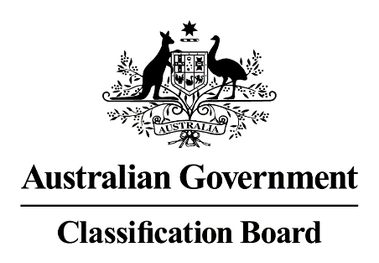

Media release—Vaxxed: from cover-up to catastrophe
The article Cinema Chain lets anti-vax film show on page 6 of The Australian, 4 August 2017, implies that the film Vaxxed: from cover-up to catastrophe has been banned by the Australian Classification Board. The Board classified Vaxxed: from cover-up to catastrophe PG with consumer advice of ‘mild themes and infrequent coarse language’ on 18 July 2017. A film classified PG can be exhibited in Australia without any restrictions on who is admitted to the screening, however, films classified PG are not recommended for children under 15 years without supervision from a parent or guardian.
When classifying films, the Board applies the Classification (Publications, Films and Computer Games) Act 1995 (the Act), the National Classification Code (the Code), and the Guidelines for the Classification of Films (the Guidelines), and classifies films as submitted. The consideration of impact and context are essential principles in the use of the Guidelines. The Act, the Code and the Guidelines are available at www.classification.gov.au.
Margaret Anderson
Acting Director
Classification Board
Media Contact: Kathryn Reidy 02 9289 7100

