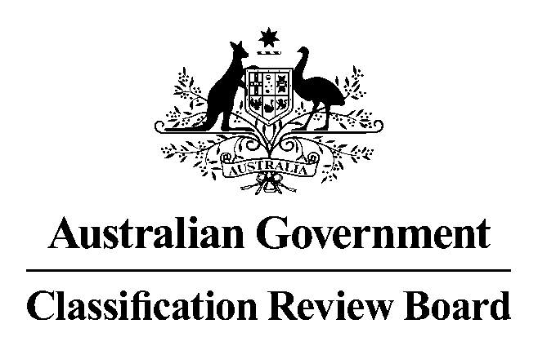

# 31 May 2016

# MEDIA RELEASE

## Classification review announced for the film Teenage Mutant Ninja Turtles: Out of the Shadows

The Classification Review Board has received an application to review the classification of the film *Teenage Mutant Ninja Turtles: Out of the Shadows.*

*Teenage Mutant Ninja Turtles: Out of the Shadows* was classified M with the consumer advice ‘Action violence’ by the Classification Board on 30 May 2016.

The Classification Review Board will meet on 7 June 2016 to consider the application. The decision and reasons will later be published on [www.classification.gov.au](http://www.classification.gov.au/).

If an individual or organisation wishes to apply for standing as an interested party to this review, please write to the Convenor of the Review Board. The names of interested parties will be disclosed in the Review Board’s final decision report, unless requested otherwise.

The closing date to lodge your application for standing as an interested party and any submissions is 3 June 2016. Please note that the Review Board can only consider submissions about *Teenage Mutant Ninja Turtles: Out of the Shadows* itself and not any other matters relating to film classification policy or issues generally.

Submissions should be emailed to [crb@classification.gov.au](mailto:crb@classification.gov.au) or sent to:

The Convenor

Classification Review Board

Locked Bag 3

HAYMARKET NSW 1240

The Classification Review Board is an independent merits review body. It makes a fresh classification decision upon receipt of an application for review. The Classification Review Board decision takes the place of the original decision made by the Classification Board.

**Media contact**

Media Enquiries Officer 02 9289 7100