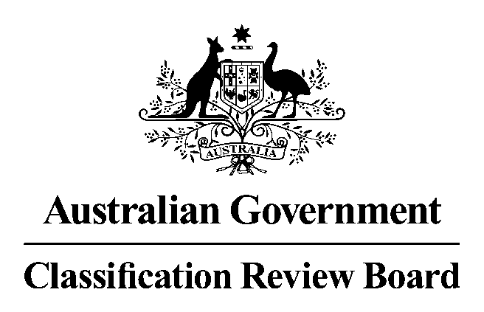

# 10 September 2015

# MEDIA RELEASE

## Blinky Bill The Movie classified G

A three-member panel of the Classification Review Board has unanimously determined that the film *Blinky Bill The Movie* is classified **G (General**) with consumer advice of “Some scenes may scare very young children”.

The overall impact of the classifiable elements in the film was no higher than very mild.

The Classification Guidelines provide that the treatment of themes should have a very low sense of threat or menace, and be justified by context. In the Classification Review Board’s opinion *Blinky Bill The Movie* warrants a G classification because the treatment of the theme of a son searching for his lost father, and threatening behaviour by some animal characters is very mild, and these scenes are always resolved positively.

The G classification is for a general audience. Consumer advice is additional information about the main content of a film which is intended to help consumers decide if they want to view this type of material.

The Classification Review Board convened today in response to an application from the original applicant, Studiocanal Pty Ltd to review the decision made by the Classification Board on 21 August 2015 to classify *Blinky Bill The Movie* **PG** (Parental guidance recommended).

In reviewing the classification, the Classification Review Board worked within the framework of the National Classification Scheme, applying the provisions of the *Classification (Publications, Films and Computer Games) Act 1995*, the National Classification Code and the *Guidelines for the Classification of Films and Computer Games*. This is the same framework used by the Classification Board.

The Classification Review Board is an independent merits review body. It makes a fresh classification decision upon receipt of an application for review. This Classification Review Board decision takes the place of the original decision made by the Classification Board.

The Classification Review Board’s reasons for this decision will appear on the Classification website when finalised.

***Statement authorised by Fiona Jolly, Acting Convenor, Classification Review Board***